Task on Monitoring- CloudTrail & CloudWatch

1) Enable cloudtrail monitoring and store the events in s3 and cloudwatch log events.
Task Title :
Enable CloudTrail and Store Logs in S3 & CloudWatch Logs
Objective :
Enable AWS CloudTrail to monitor all API events and store them securely in S3 and CloudWatch Logs for auditing and monitoring.
Prerequisites :
- IAM Admin / CloudTrail permissions
- S3 bucket (CloudTrail can create)
- CloudWatch Log Group / IAM role for CloudTrail

Step-by-Step Implementation (With Evidence)
Step 1: Create a CloudTrail Trail
Console Path:
AWS Console → CloudTrail → Trails → Create Trail
Explanation:
Creates a trail to capture management
Evidence:
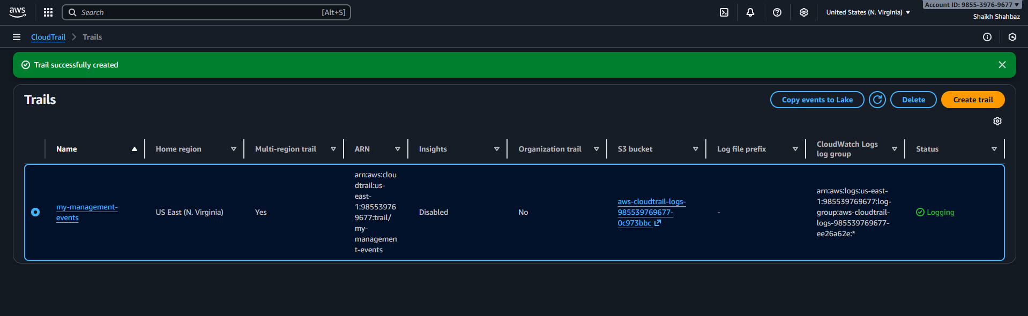

Step 2: Configure S3 Bucket for CloudTrail
Explanation:
S3 bucket stores all CloudTrail logs.
Evidence:
(Screenshot of bucket configuration)
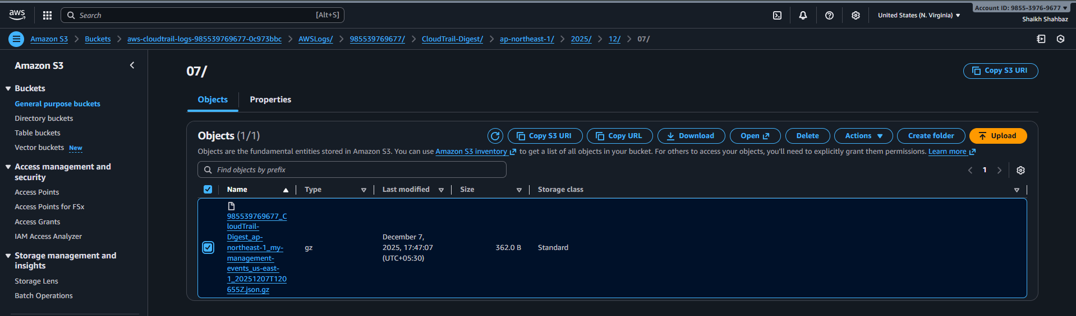
Step 3: Enable CloudWatch Logs Integration
Console Path:
Trail settings → CloudWatch Logs → Enable
CloudTrail auto-creates:
- Log group
- IAM role
Evidence:
(Screenshot of CloudWatch Logs integration page)
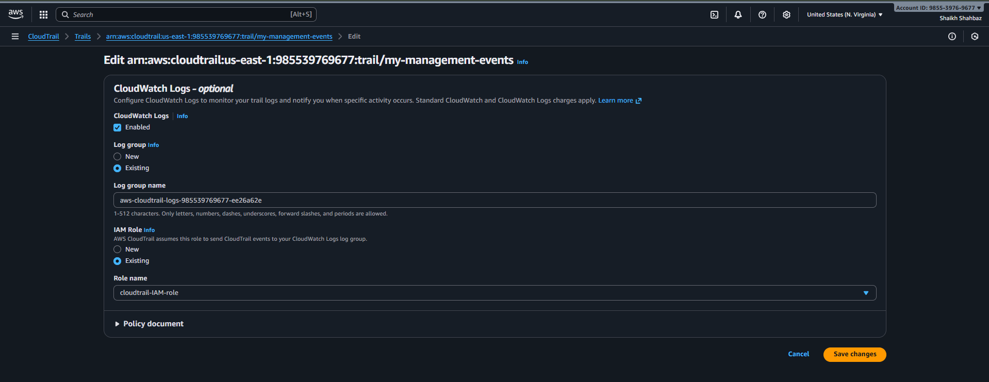
Step 4: Your trail is been created
Download the trail to view all trial logs
Evidence:
(Screenshot showing trail created & Logging: ON)

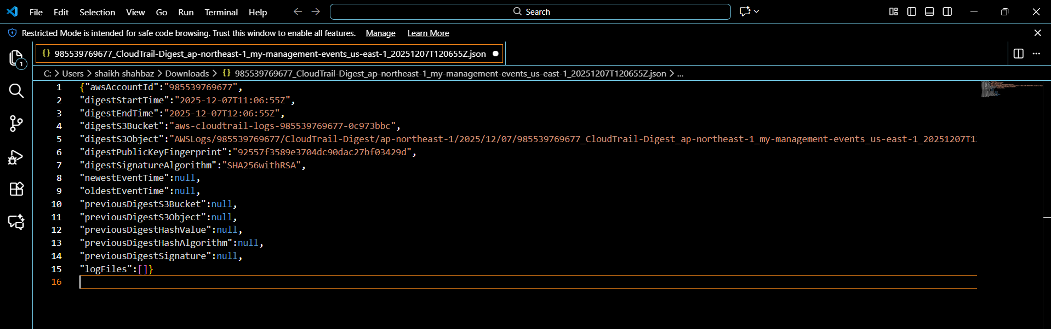
Validation Steps (With Evidence)
Validation 1: CloudTrail Logging Status
CloudTrail → Trails → Should show Logging: ON
Evidence:
(Screenshot of trail status)
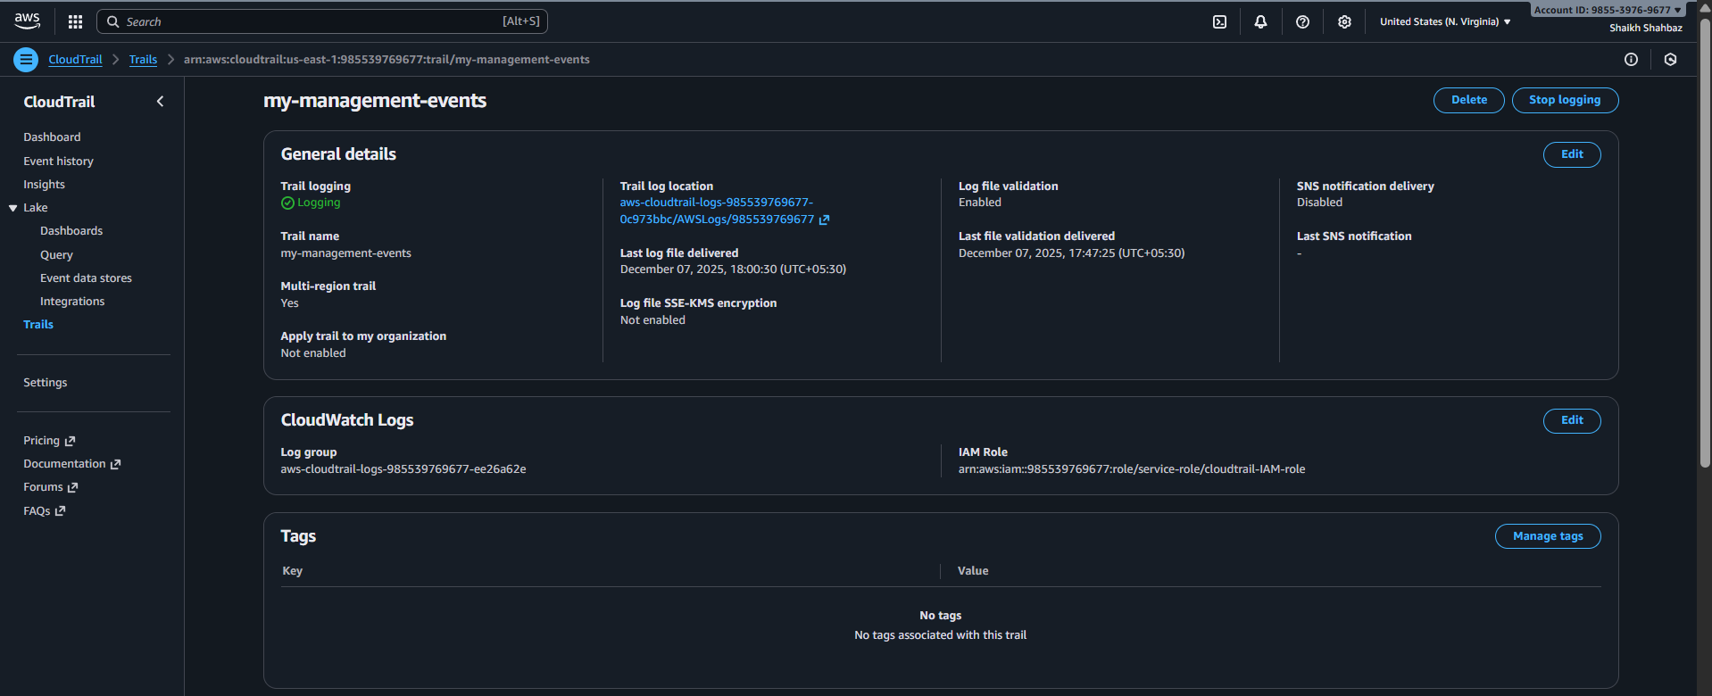
Validation 2: Logs in S3
Go to S3 bucket → Check logs folder
AWSLogs/<account-id>/CloudTrail/...
Evidence:
(Screenshot of S3 log files)

Issues Faced
None encountered.
Conclusion
CloudTrail successfully enabled and configured to send logs to S3 and CloudWatch.

2) Enable SNS for cloudtrial to send alert on email.
Task Title :
Enable SNS Alerts for CloudTrail Using CloudWatch Metric Filters
Objective :
Send email notifications for critical CloudTrail events (e.g., unauthorized API calls).
Prerequisites :
- CloudTrail enabled
- CloudWatch Logs enabled
- Valid email address
- IAM SNS permissions

Step-by-Step Implementation (With Evidence)
Step 1: Create an SNS Topic
Console Path:
SNS → Topics → Create Topic
Name: cloudtrail-alert
Display name – cloudtrail-alert
Evidence:
(SNS topic screenshot)
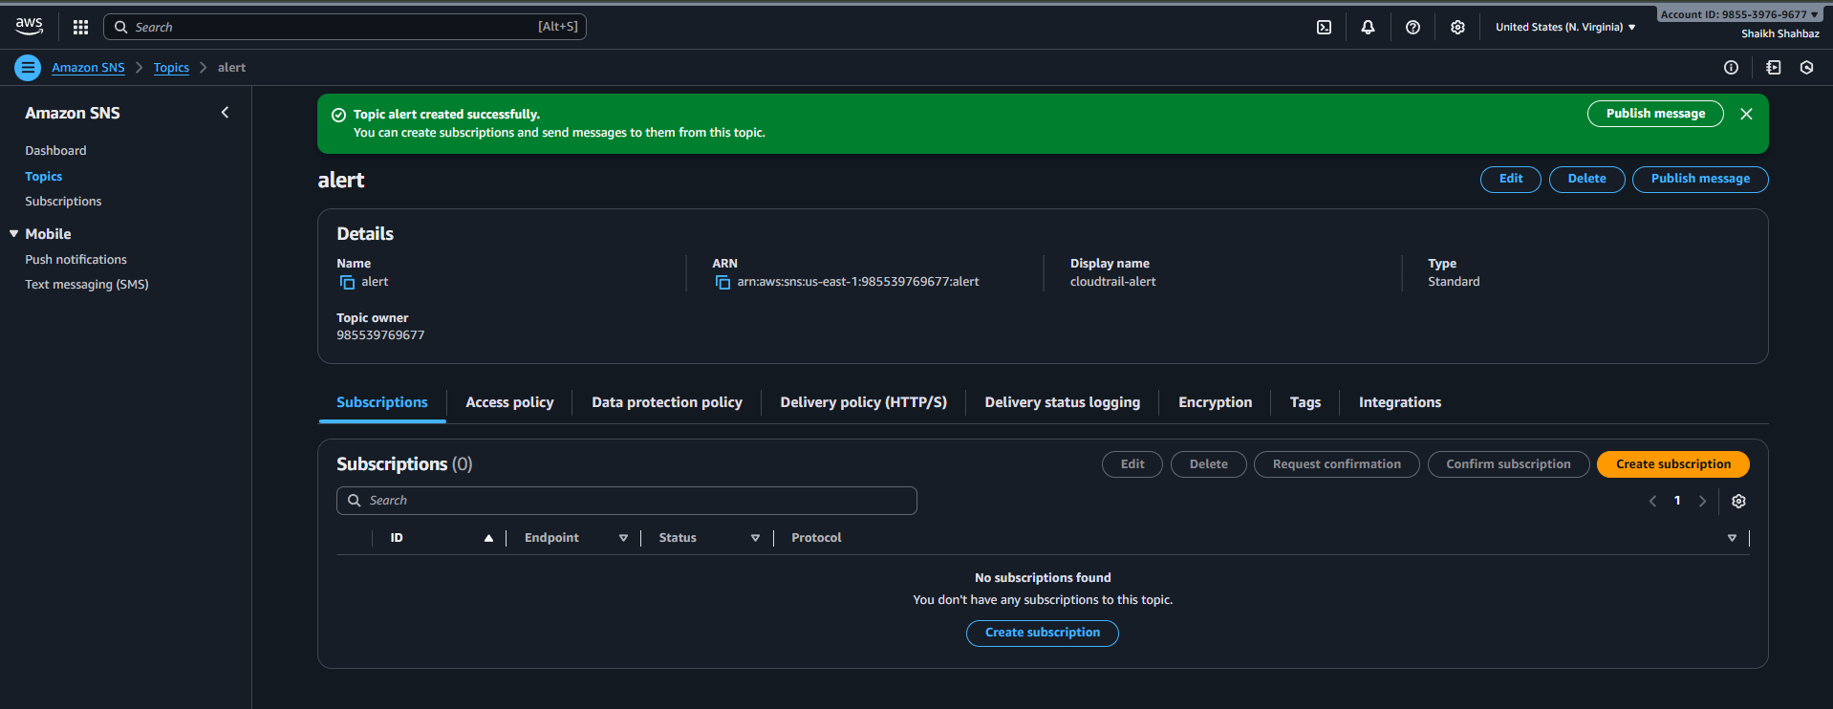
Step 2: Subscribe Email
Protocol: Email
Enter your email.
Confirm subscription from your inbox.
Evidence:
(Subscription confirmation screenshot)
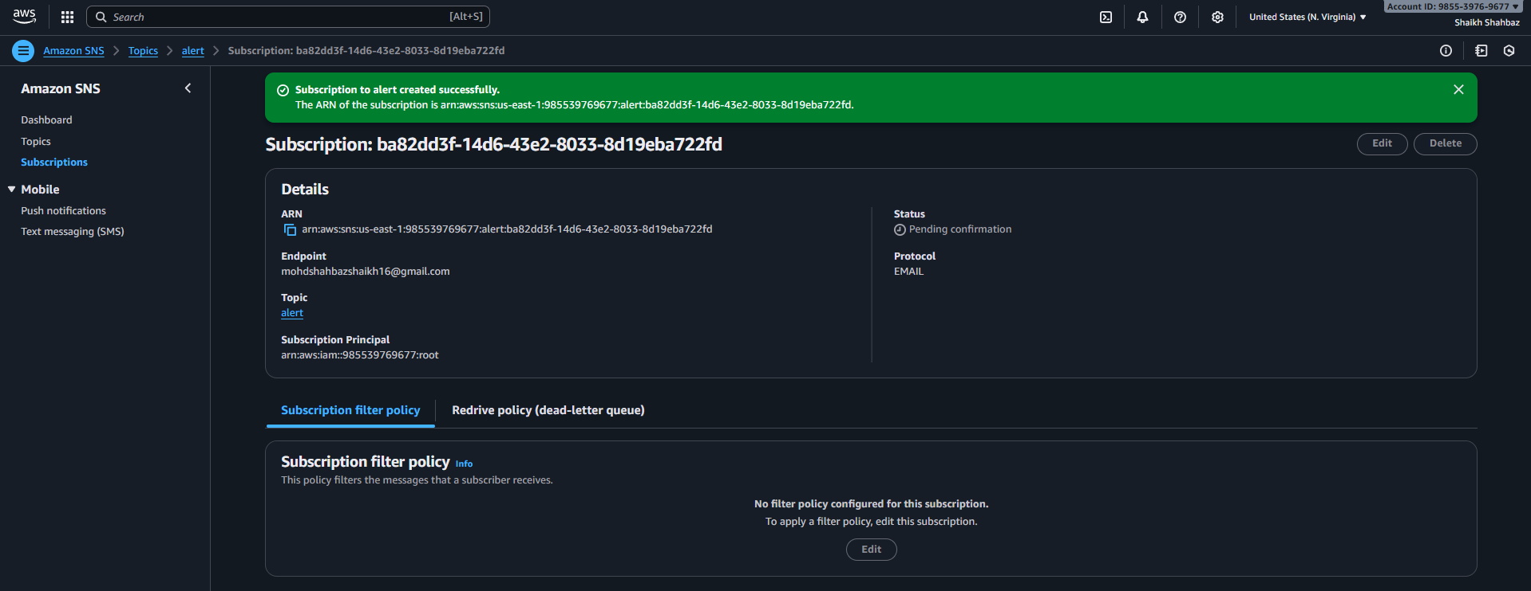
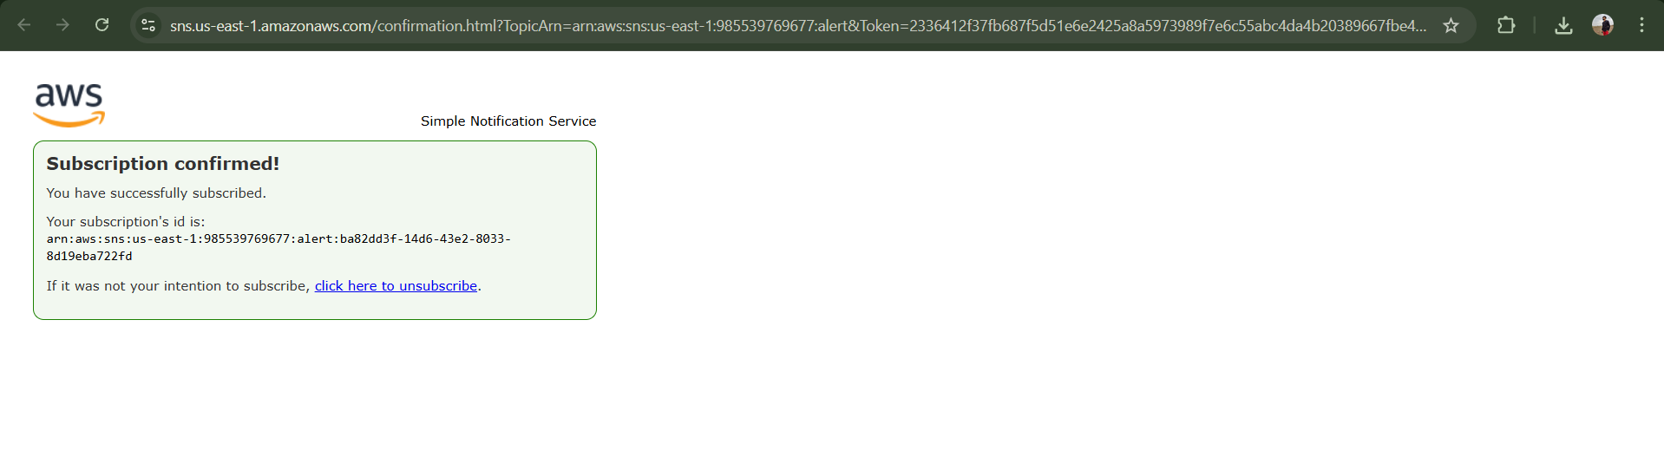
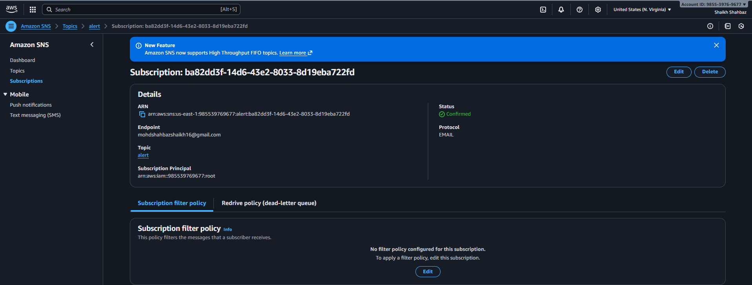
Step 3: Create CloudWatch Metric Filter
Console Path:
CloudWatch → Logs → Log Groups → /aws/cloudtrail/mytrail
Filter example:
{ $.errorCode = "*UnauthorizedOperation" }
Evidence:
(Metric filter screenshot)
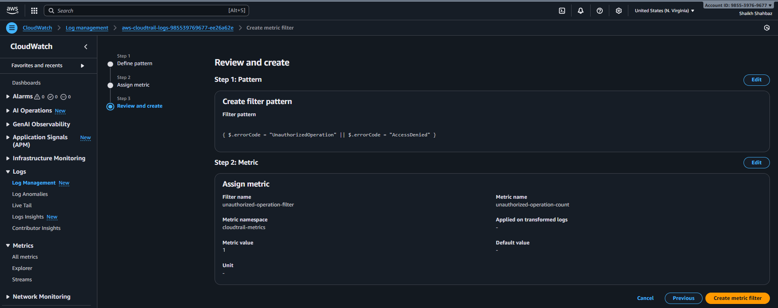
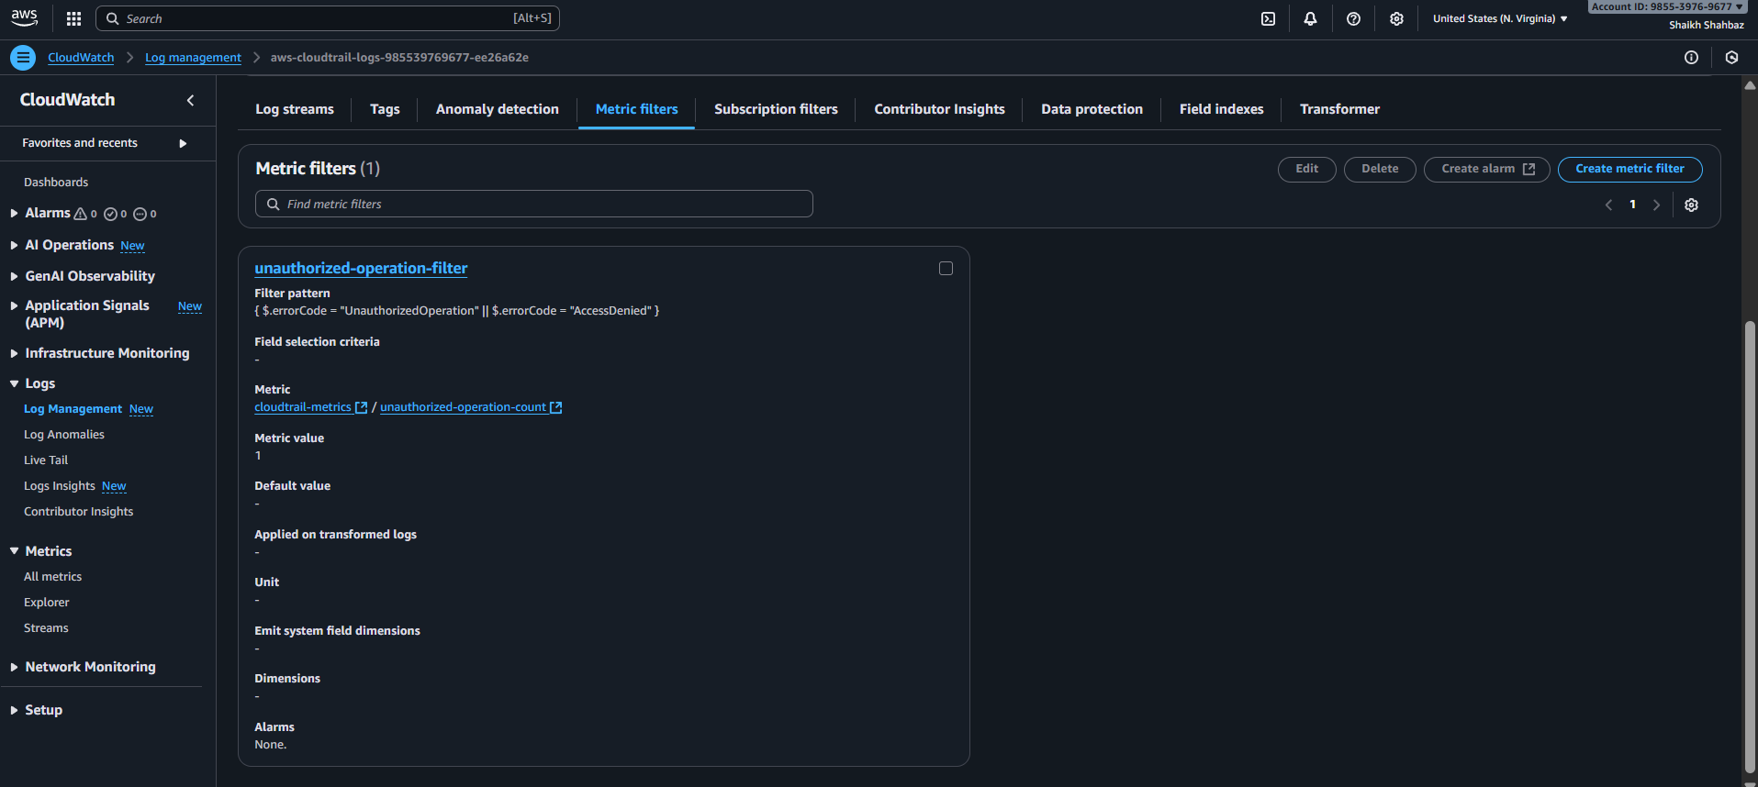

Step 4: Create Alarm for the Filter
Console Path:
CloudWatch → Alarms → Create alarm
Notification: cloudtrail-alert-topic
Evidence:
(Alarm configuration screenshot)
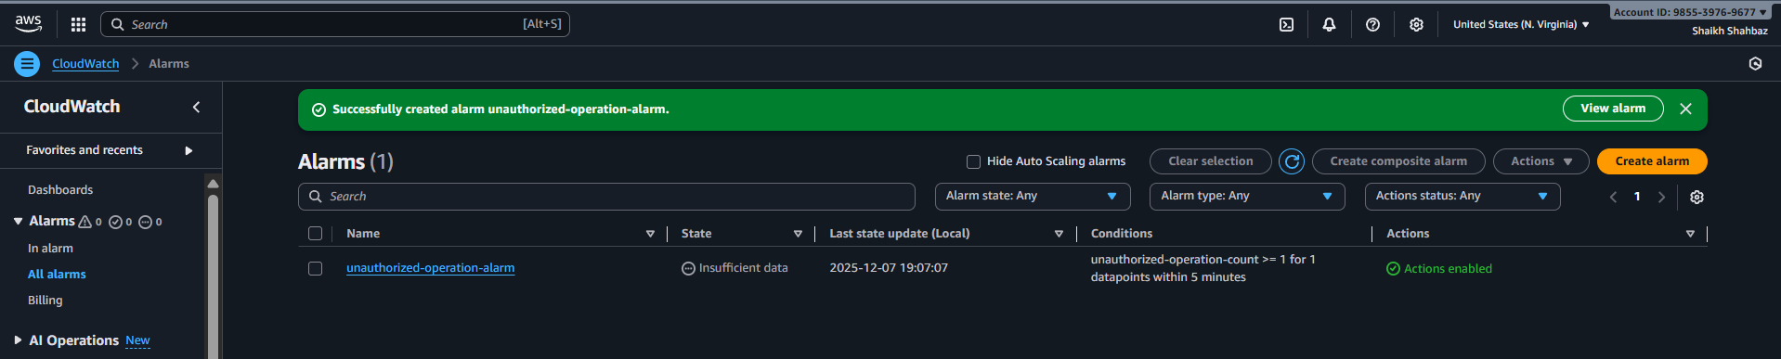
Validation Steps (With Evidence)
Validation 1: SNS Email Delivered
Trigger a test alert.
Evidence:
(Email screenshot)
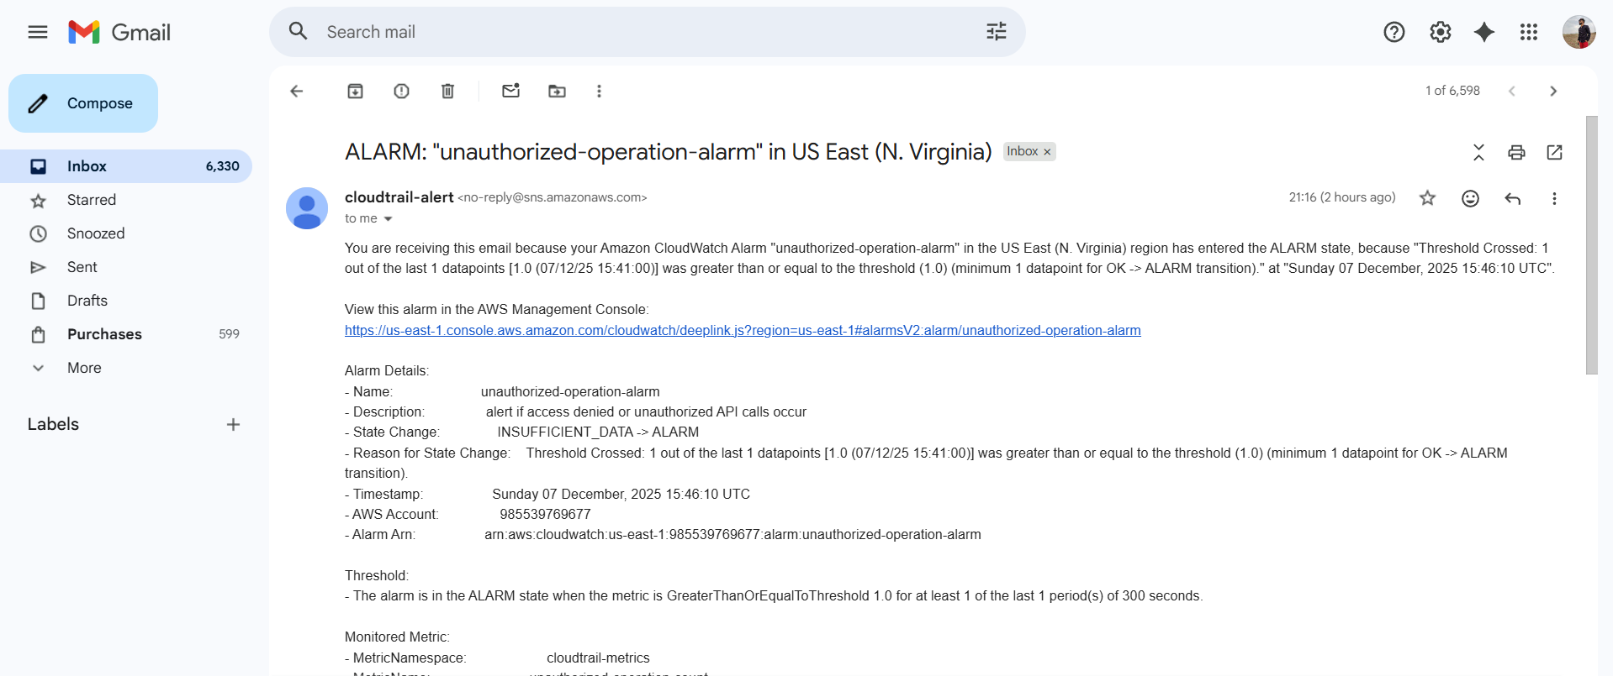
Validation 2: Metric Filter Counting Logs
Metric should show non-zero datapoints after an event.
Evidence:
(Metric graph screenshot)
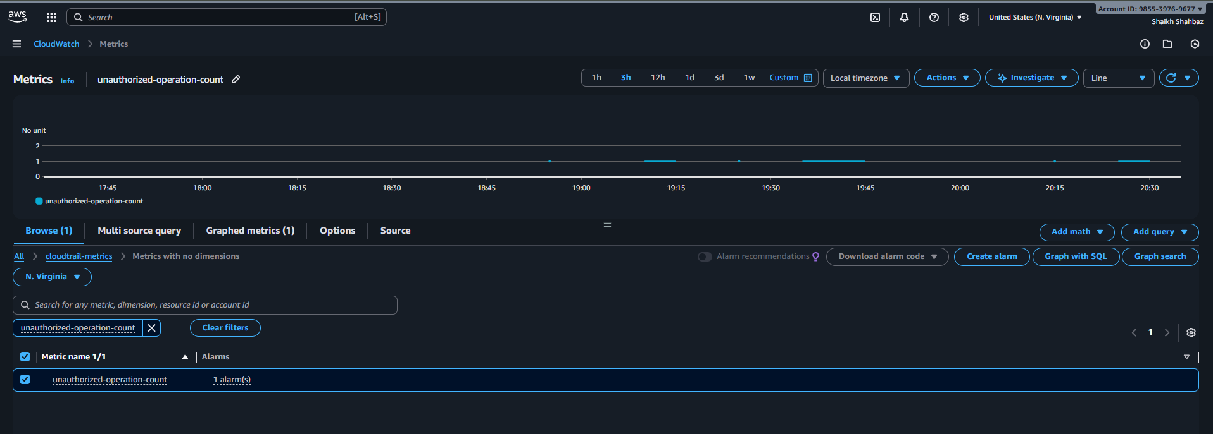
Issues Faced :
Email not arriving → Had to confirm subscription.
Conclusion :
SNS alerting for CloudTrail successfully configured.

3) Configure cloud watch monitoring and record the cpu utilization and other metrics of ec2.
Task Title :
Install & Configure CloudWatch Agent on EC2 for System Monitoring
Objective :
Collect CPU, Memory, Disk, and EC2 status metrics using CloudWatch Agent.
Prerequisites :
- EC2 instance
- IAM Role with CloudWatch permissions
- SSH Access
- Internet access (or SSM)

Step-by-Step Implementation (With Evidence)
Step 1: Install CloudWatch Agent
SSH into EC2.
Amazon Linux:
sudo yum install amazon-cloudwatch-agent -y
Evidence:
(Terminal screenshot)
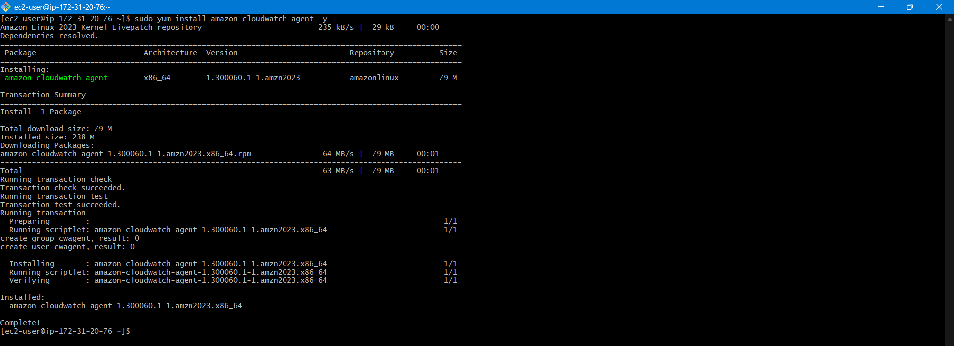
Step 2: Configure the Agent
Run config wizard:
sudo /opt/aws/amazon-cloudwatch-agent/bin/amazon-cloudwatch-agent-config-wizard
Evidence:
(Wizard terminal output)
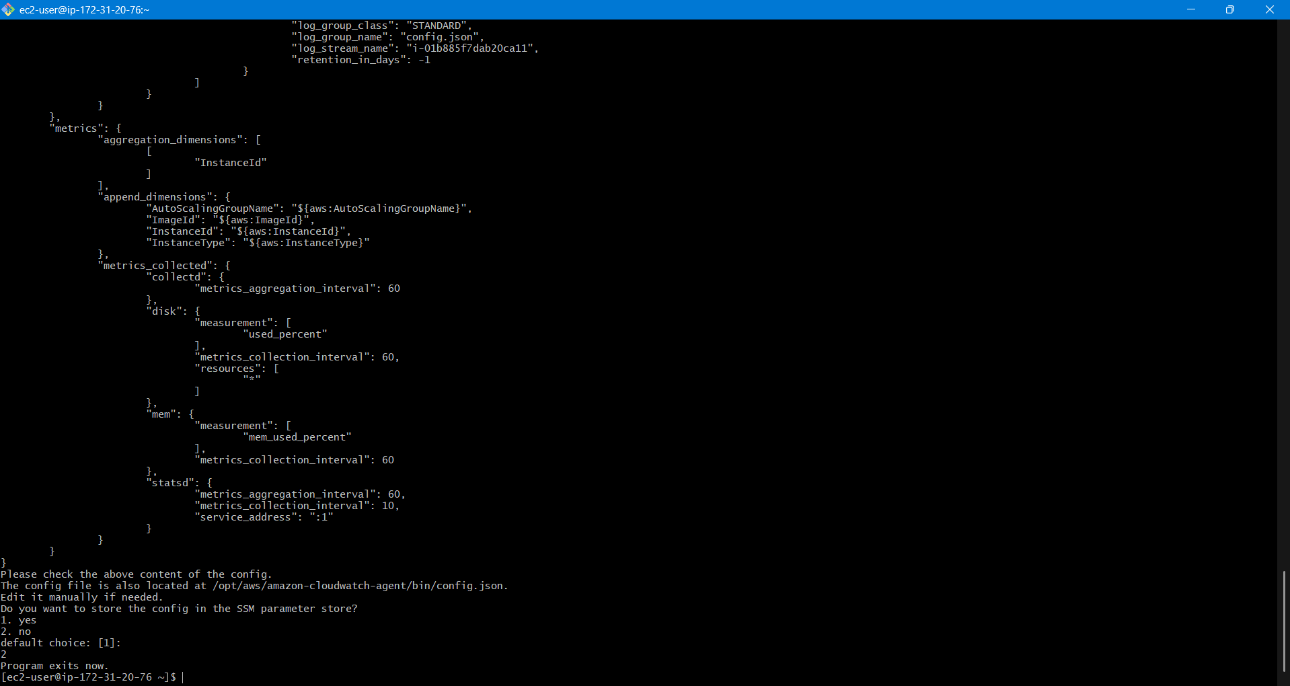
Step 3: Start the Agent
sudo systemctl start amazon-cloudwatch-agent
sudo systemctl enable amazon-cloudwatch-agent
Evidence:
(systemctl status agent screenshot)
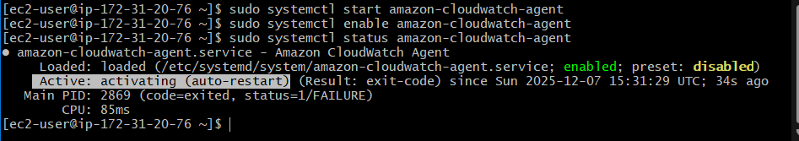
Validation Steps (With Evidence)
Validation 1: Agent Running
systemctl status amazon-cloudwatch-agent
Evidence: Screenshot
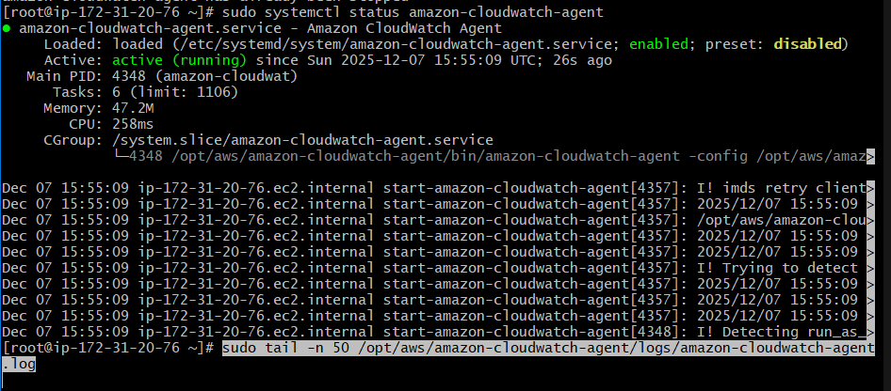
Validation 2: Metrics Visible
CloudWatch → Metrics → CWAgent namespace
Evidence: Screenshot
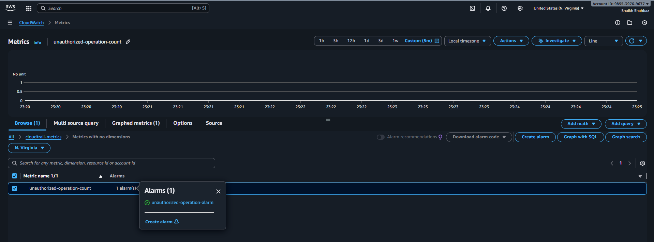
Issues Faced :
Had to wait for email and logs to form.
Conclusion :
CloudWatch Agent installed and EC2 metrics are available.

4) Create one alarm to send alert to email if the cpu utilization is more than 70 percent.
Task Title :
Configure CloudWatch Alarm for CPU > 70%
Objective :
Create a CPU alarm that triggers an SNS email notification when load exceeds 70%.
Prerequisites :
- SNS Topic
- CloudWatch metrics
- EC2 instance

Step-by-Step Implementation (With Evidence)
Step 1: Create Alarm
Console Path:
CloudWatch → Alarms → Create Alarm
Metric:
- EC2 → Per-instance metrics → CPUUtilization
Evidence:
(Metric selection screenshot)
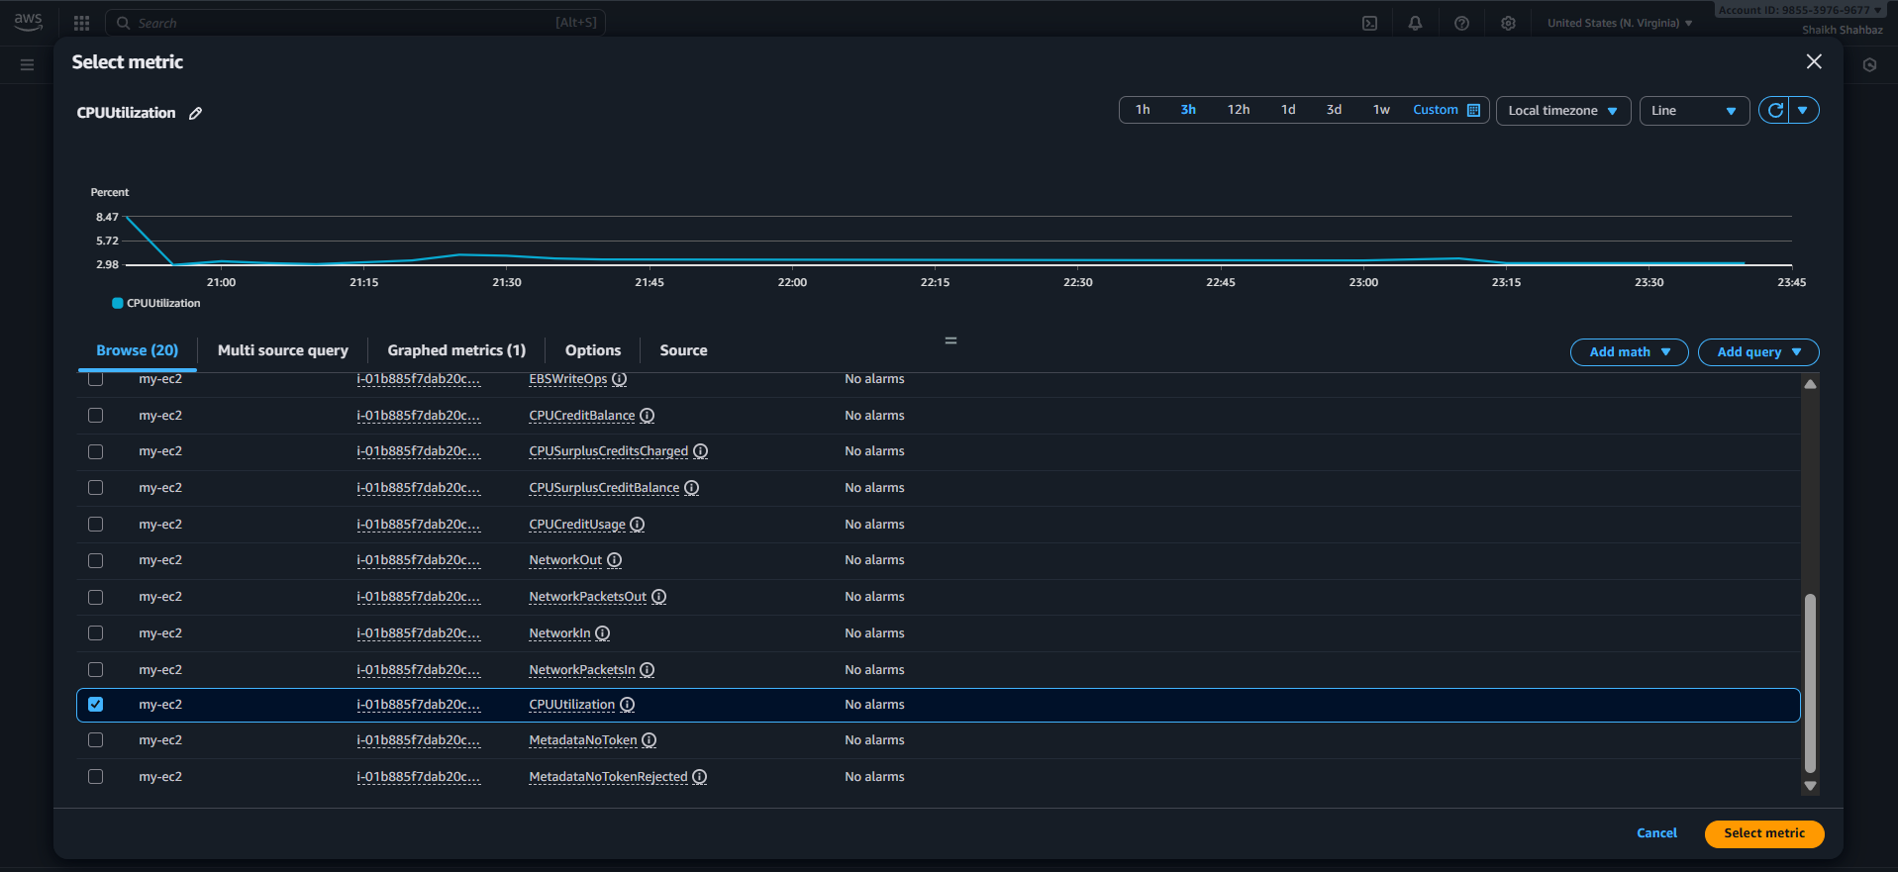
Step 2: Configure Threshold
- Static threshold
- CPU > 70%
- Period: 5 minutes
Evidence:
(Threshold screenshot)
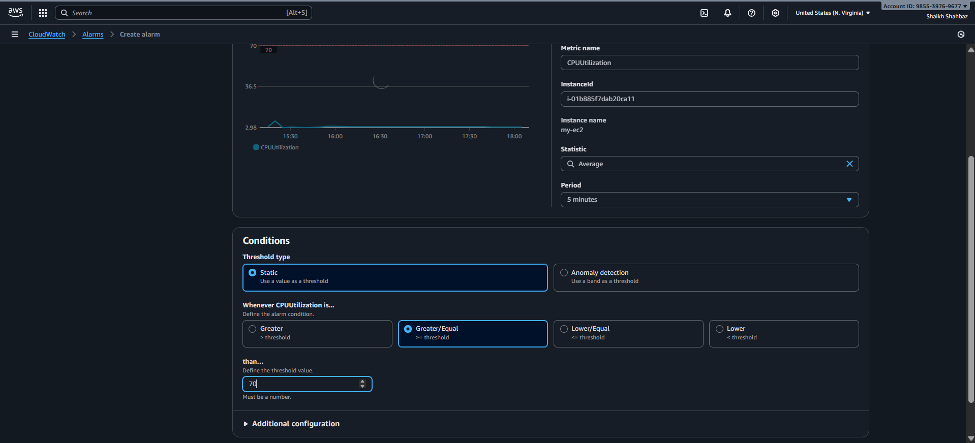
Step 3: Configure Alert Action
Notification target: high-cpu-alert
Evidence:
(SNS action screenshot)
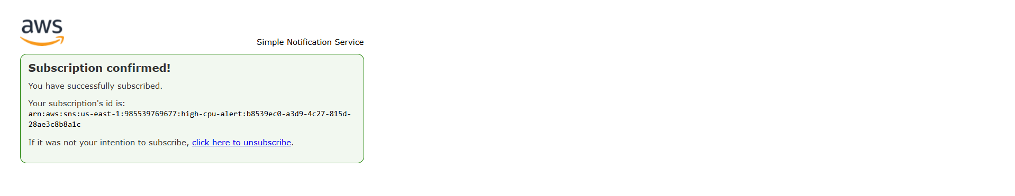
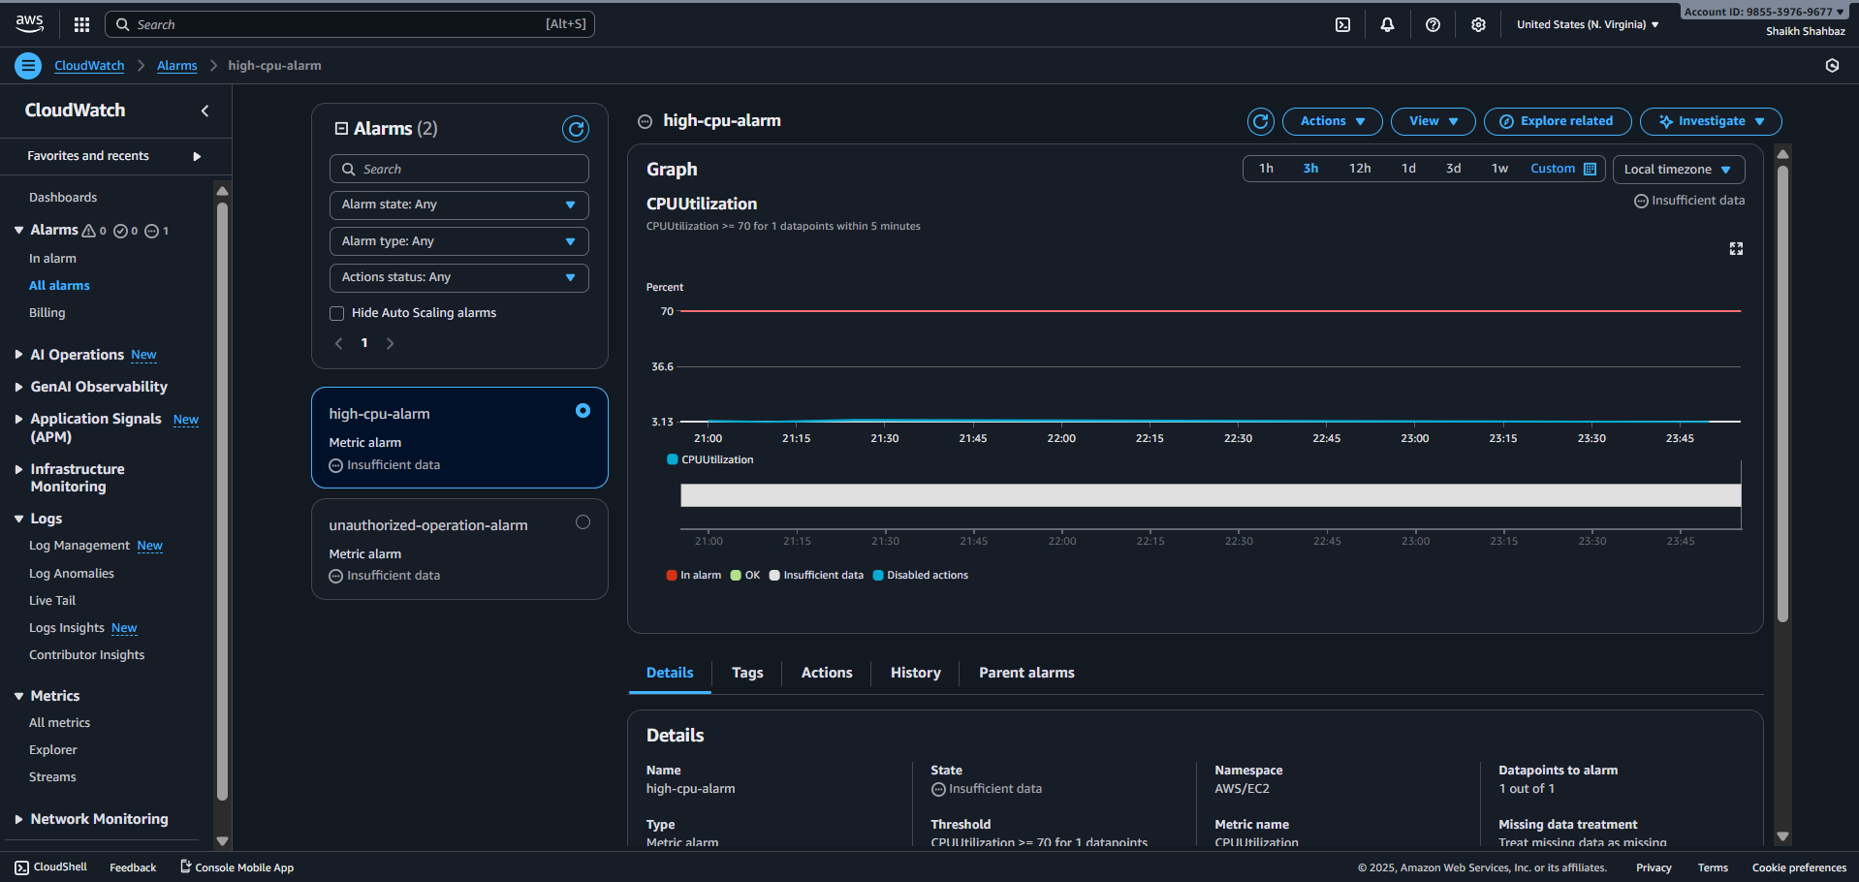
Validation Steps (With Evidence)
Validation 1: CPU Stress Test
Run:
sudo yum install stress -y
stress --cpu 2 --timeout 60
Evidence: CPU spike graph screenshot
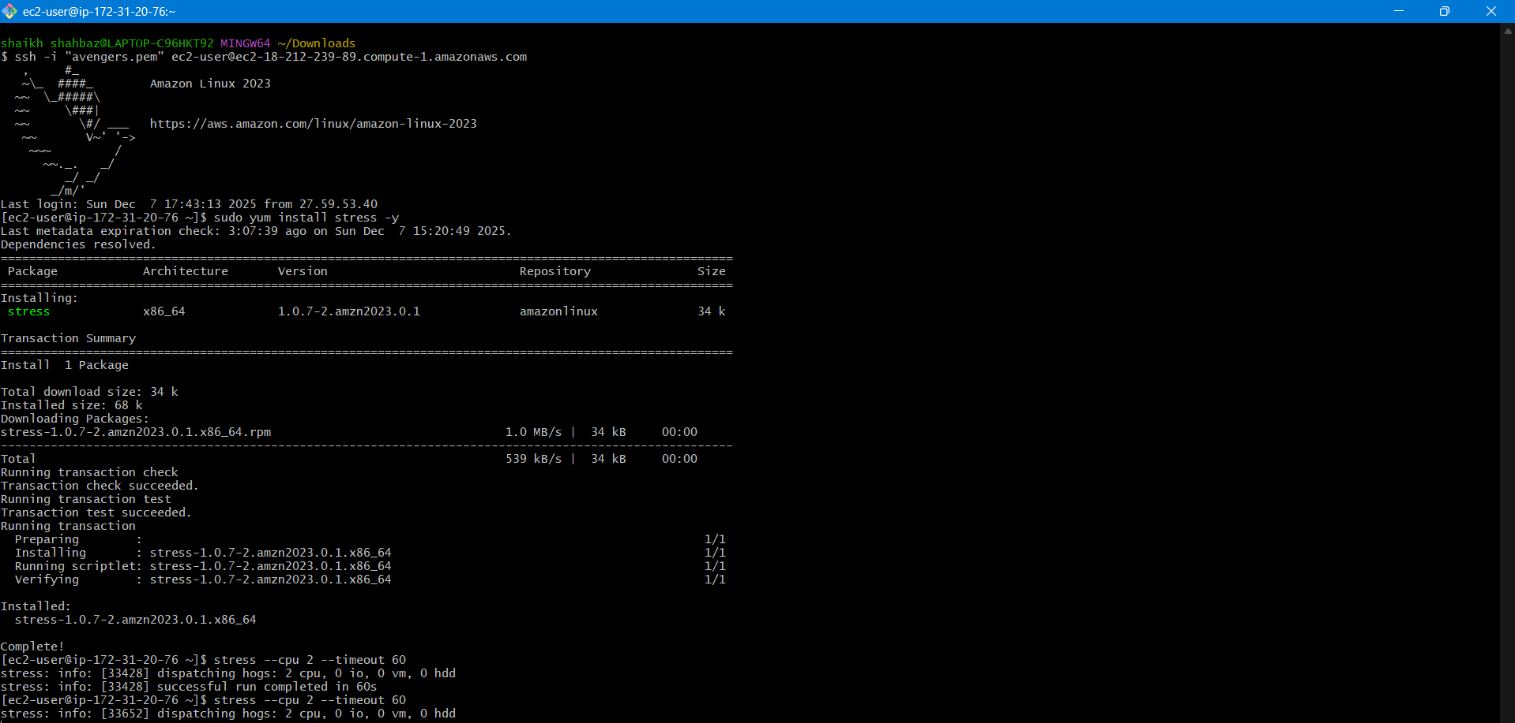
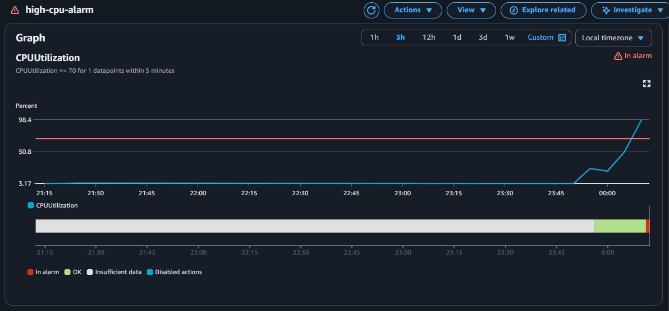
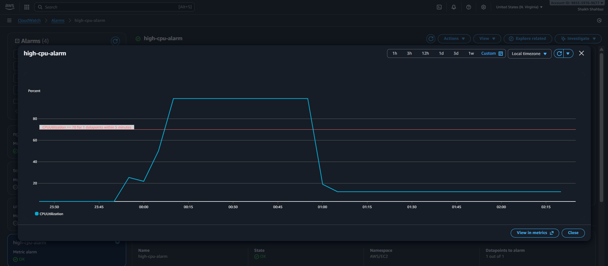
Validation 2: SNS Email Received
Evidence: Email screenshot
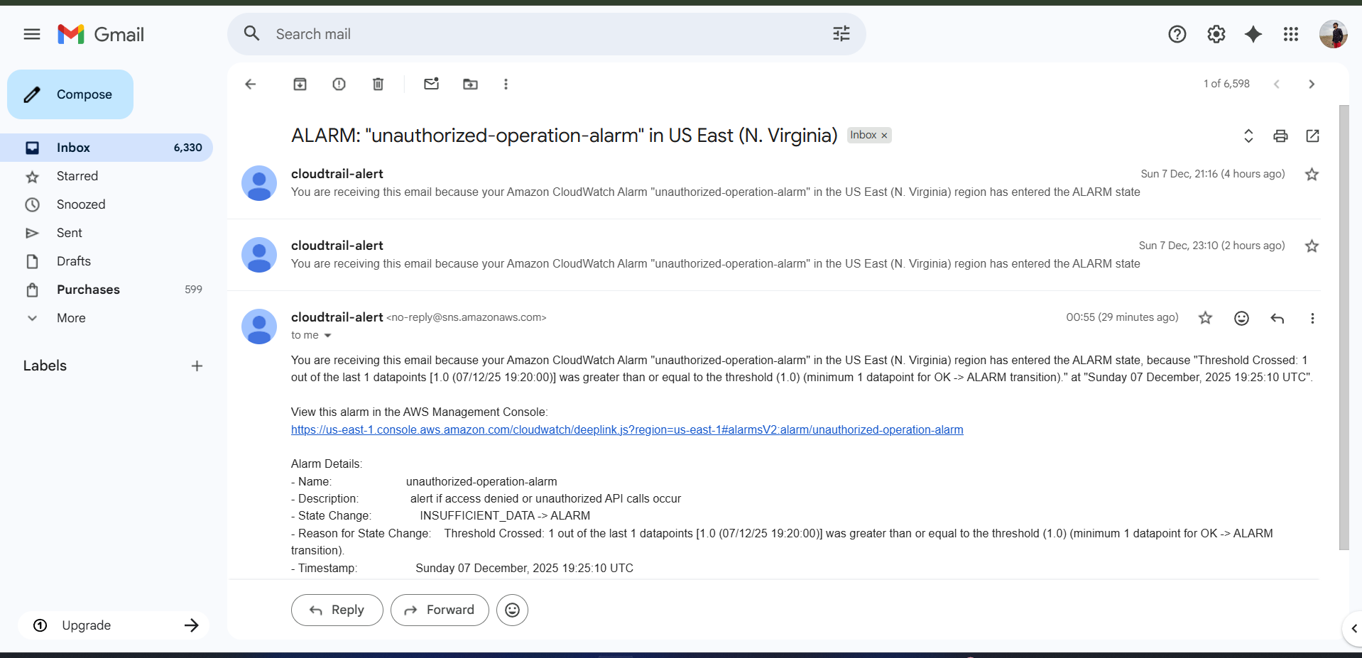
Issues Faced:
Had to wait for CPU utilization to cross 70%.
For that I have applied stress multiple time and then checked for cpu utilization using top command multiple times.
Conclusion:
CPU alarm configured successfully.

5) Create Dashboard and monitor tomcat service wether it is running or not and send the alert.
Task Title :
Monitor Tomcat Service Using Custom CloudWatch Metrics
Objective :
Track Tomcat service uptime and trigger alerts if service stops.
Prerequisites :
- EC2 instance with Tomcat installed
- CloudWatch Agent or AWS CLI installed
- IAM Role with CloudWatch permissions

Step-by-Step Implementation (With Evidence)
Step 1: Create Tomcat Status Script
sudo vi /opt/tomcat-status.sh
Add:
#!/bin/bash
if systemctl is-active --quiet tomcat; then
status=1 (Service-active)
else
status=0 (Service-inactive)
fi

aws cloudwatch put-metric-data \
--metric-name TomcatStatus \
--namespace "Custom/Tomcat" \
--value $status
Evidence:
Screenshot of script
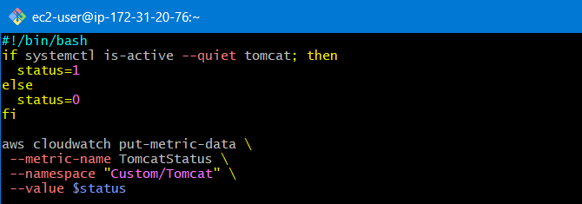
Step 2: Enable Script via Cron
crontab -e
Add:
* * * * * /opt/tomcat-status.sh
Evidence:
Cron screenshot
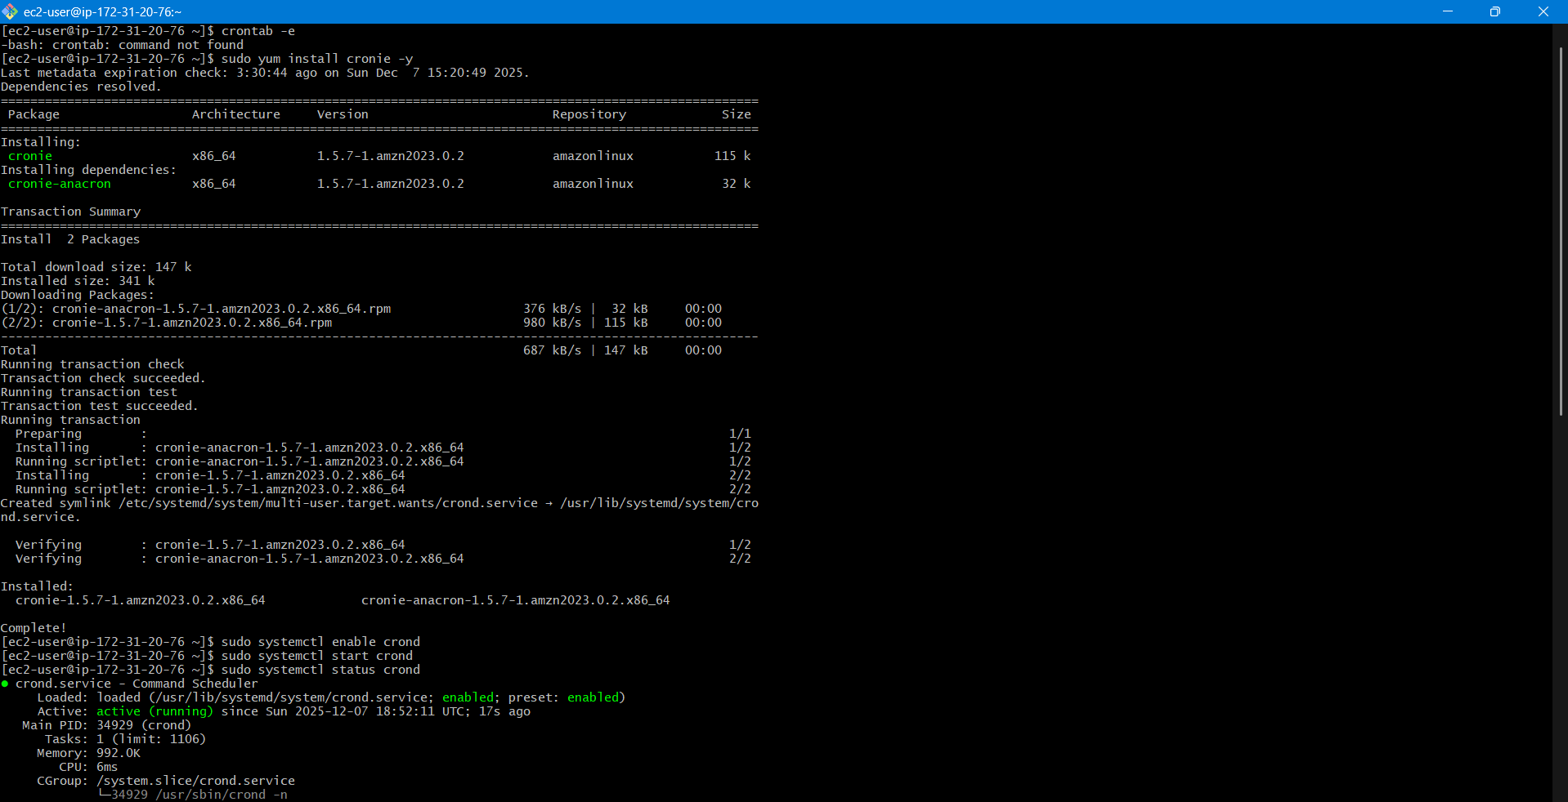
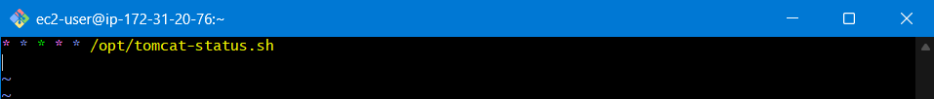
Step 3: Create Alarm
Metric: Custom/Tomcat → TomcatStatus
Alarm when value = 0
Evidence: Alarm screenshot
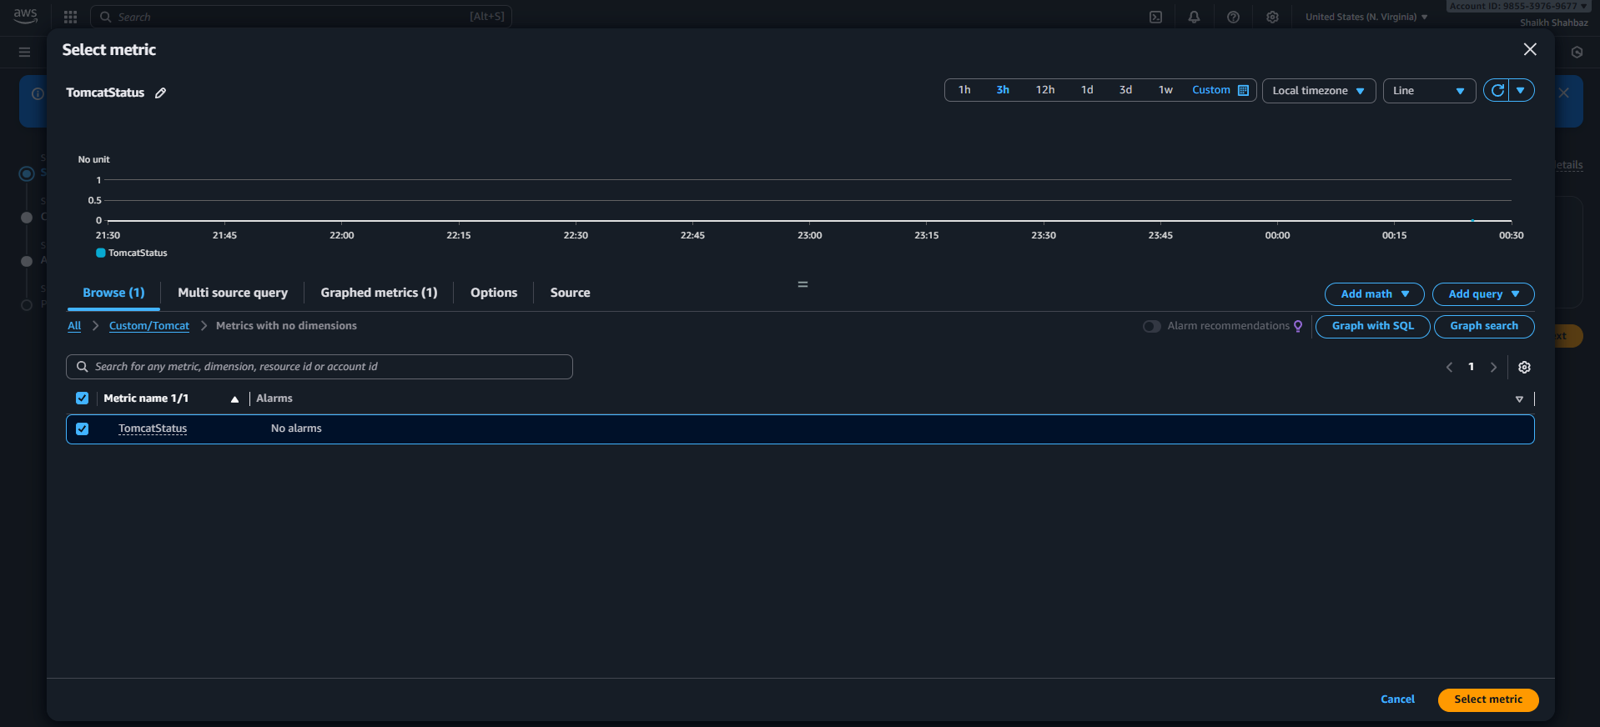
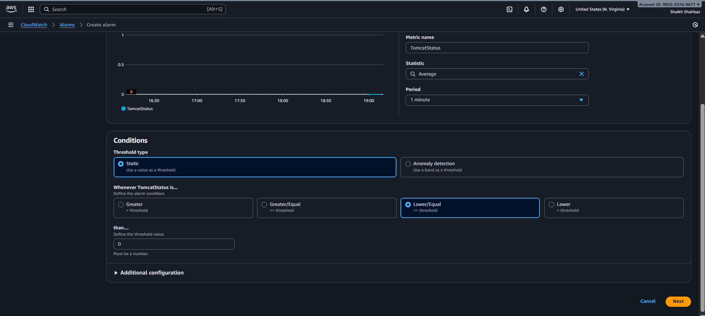
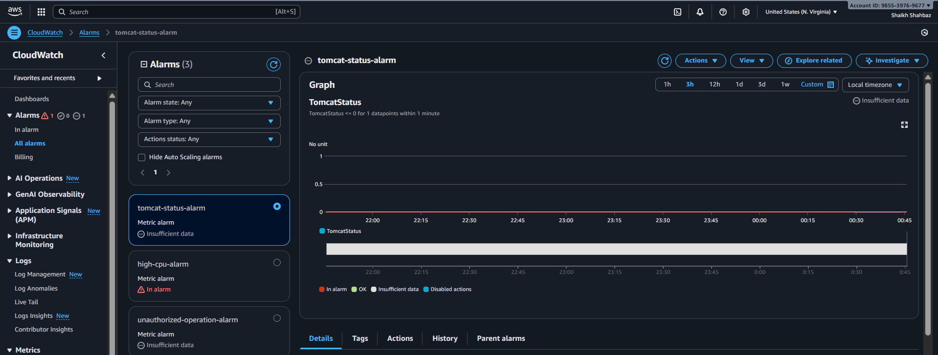
Step 4: Add Dashboard Widget
CloudWatch → Dashboard → Add Widget → Line Chart
Select metric: TomcatStatus
Evidence: Dashboard screenshot
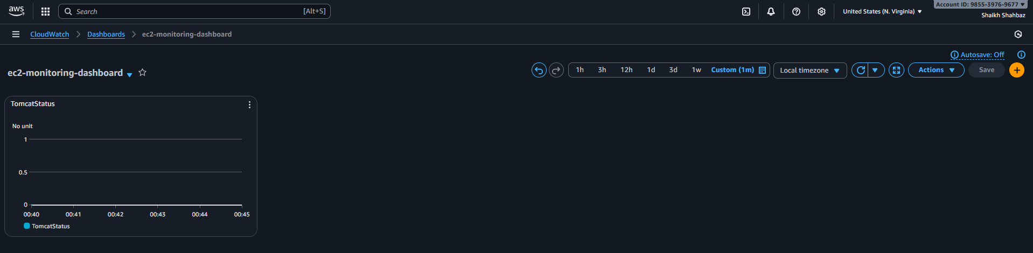
Validation Steps (With Evidence)
Validation 1: Stop Tomcat
sudo systemctl stop tomcat
Evidence: Service inactive screenshot
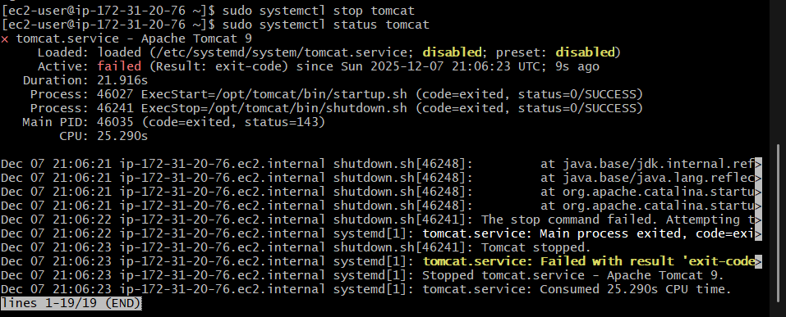
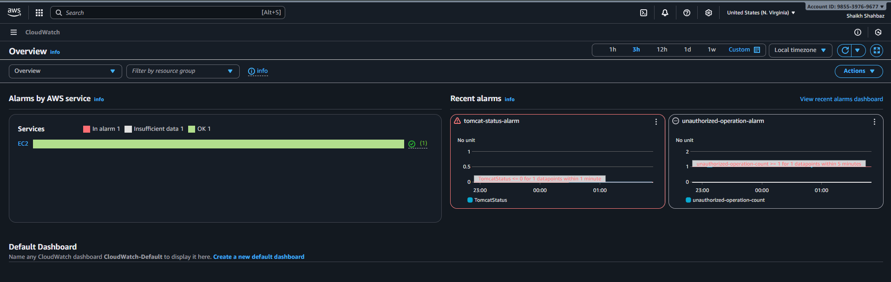
Validation 2: Alarm Trigger
Evidence: Alarm in ALARM state
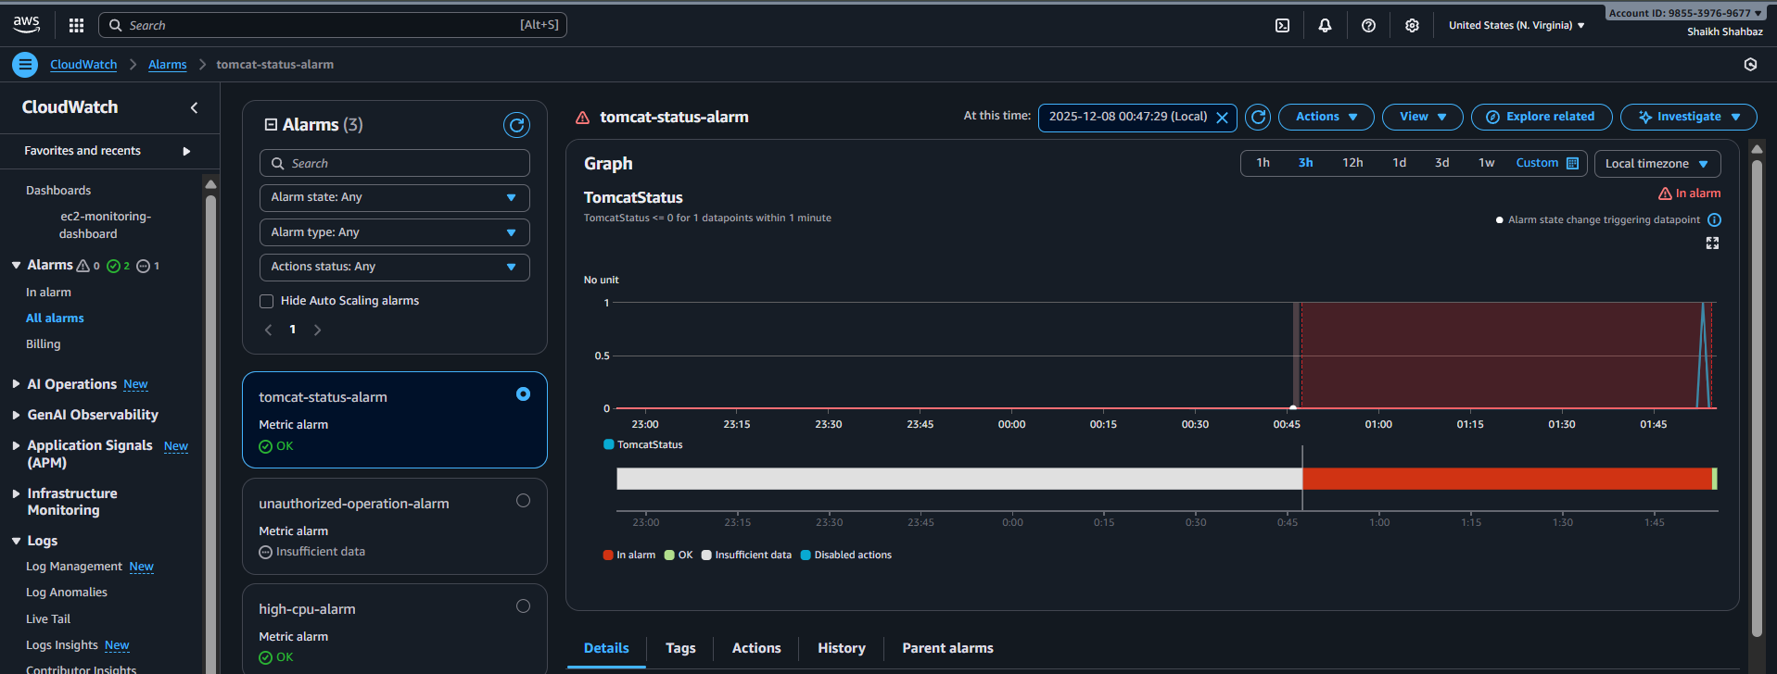
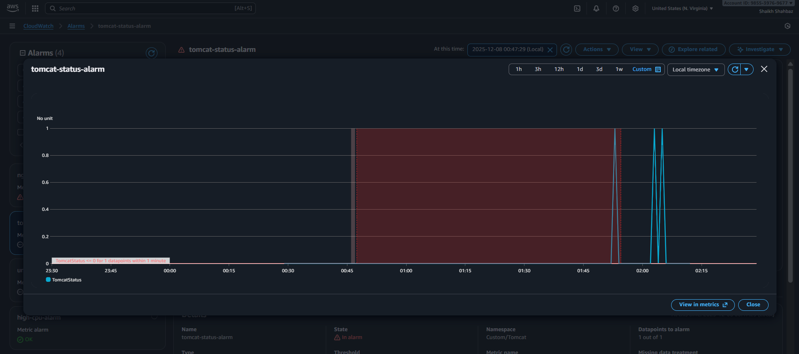
Validation 3: SNS Email Received
Evidence: Email screenshot
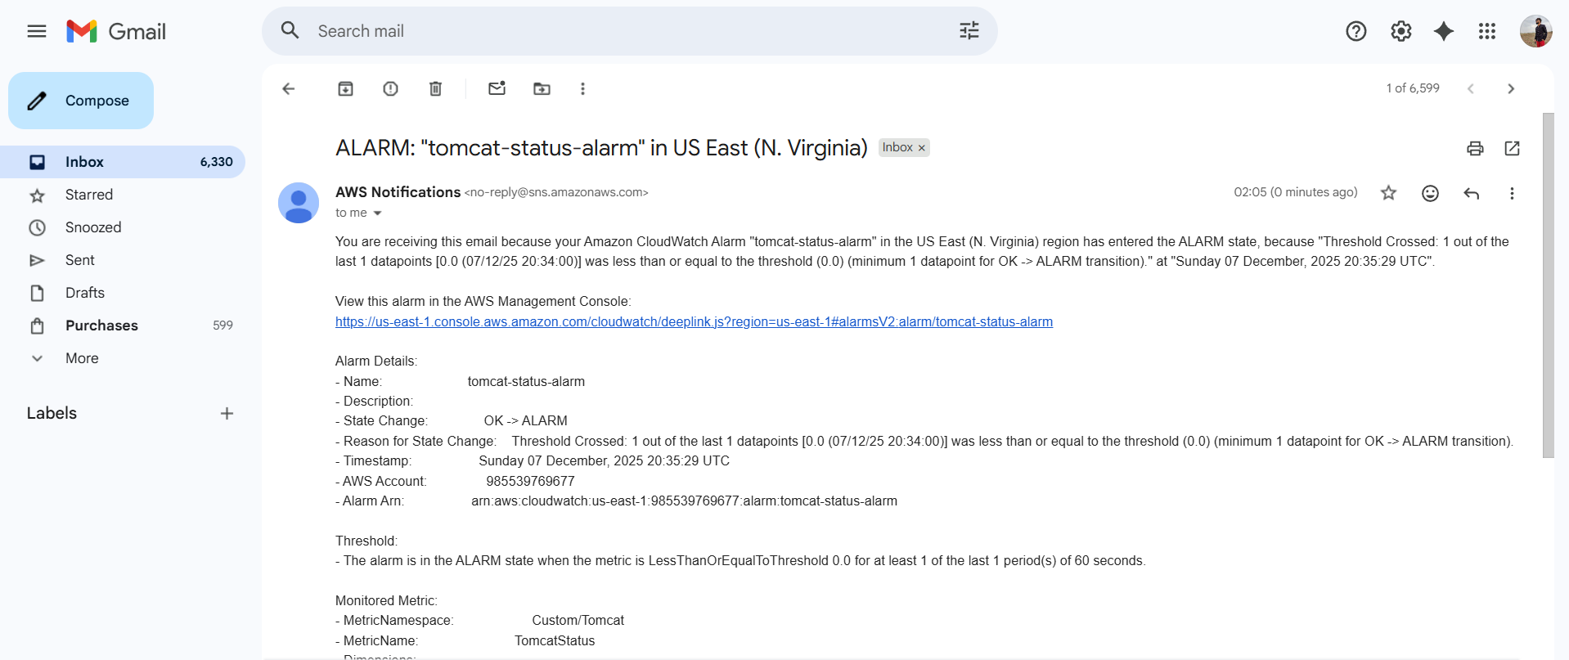
Issues Faced :
None.
Conclusion :
Tomcat monitoring & alerts configured successfully.

6) Create Dashboard and monitor nginx service to send the alert if nginx is not running.
Task Title :
Monitor Nginx Service Using Custom CloudWatch Metrics
Objective :
Monitor Nginx service health and receive alerts when it stops.
Prerequisites :
- EC2 with Nginx installed
- AWS CLI
- CloudWatch write permissions

Step-by-Step Implementation (With Evidence)
Step 1: Create Nginx Status Script
sudo vi /opt/nginx-status.sh
Add:
#!/bin/bash
if systemctl is-active --quiet nginx; then
status=1 (Service-active)
else
status=0 (Service-inactive)
fi

aws cloudwatch put-metric-data \
--metric-name NginxStatus \
--namespace "Custom/Nginx" \
--value $status
Evidence: Script screenshot
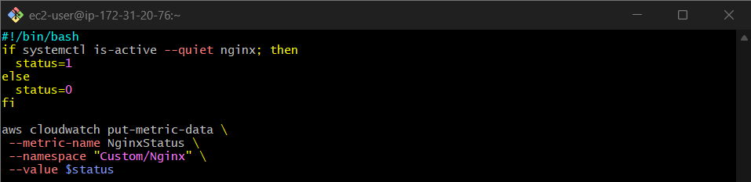
Step 2: Schedule with Cron
* * * * * /opt/nginx-status.sh
Evidence: Cron screenshot
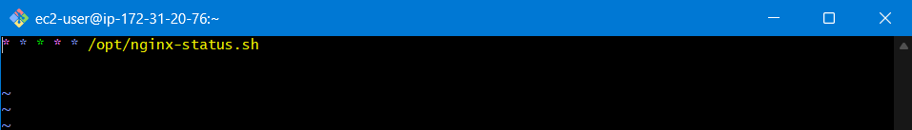
Step 3: Create Alarm for Nginx
Alert when:
NginxStatus = 0 (Service-inactive)
Evidence: Alarm screenshot
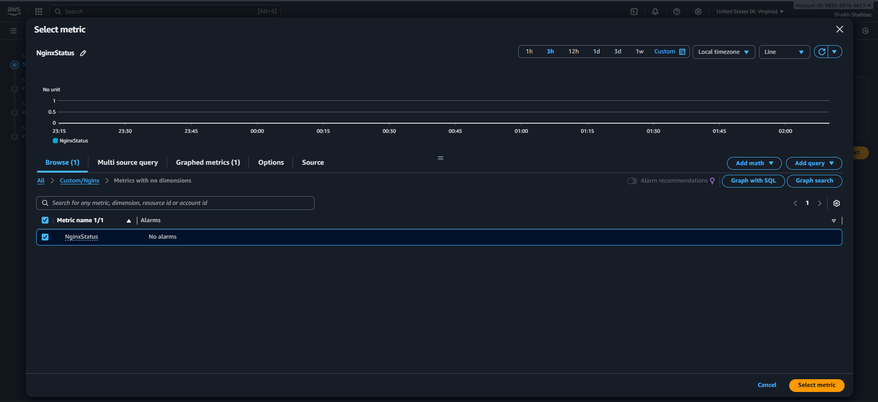
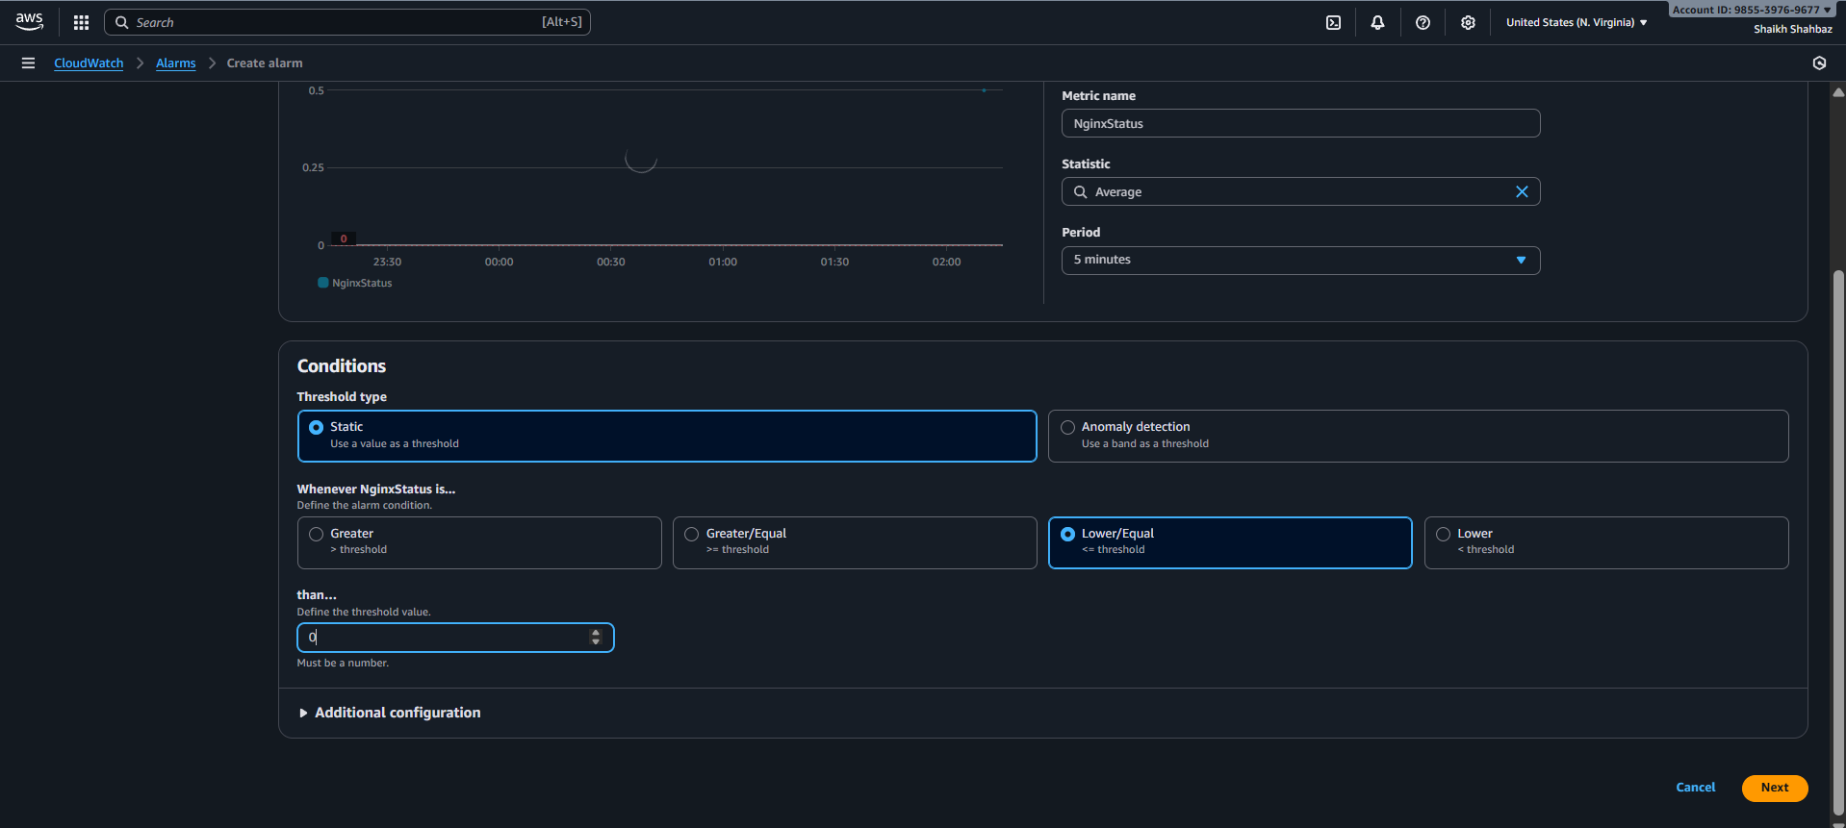
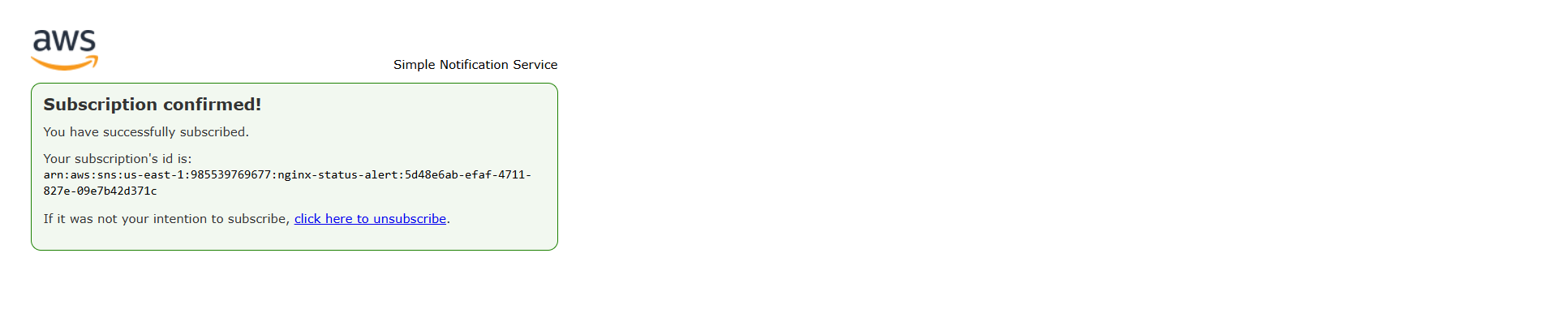
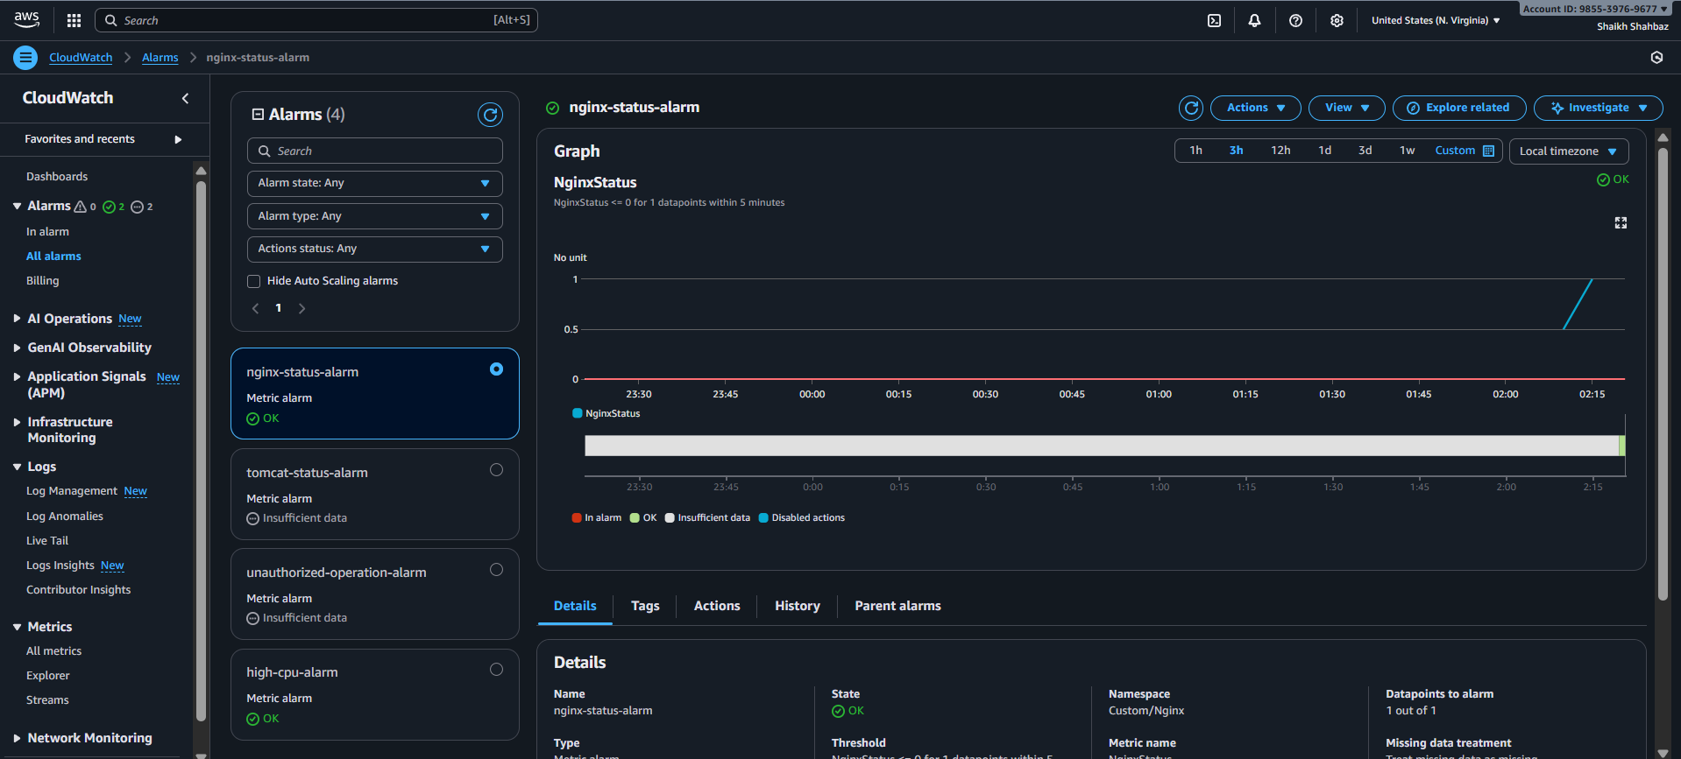
Step 4: Add Dashboard Widget
Widget: Line
Metric: Custom/Nginx → NginxStatus
Evidence: Dashboard screenshot
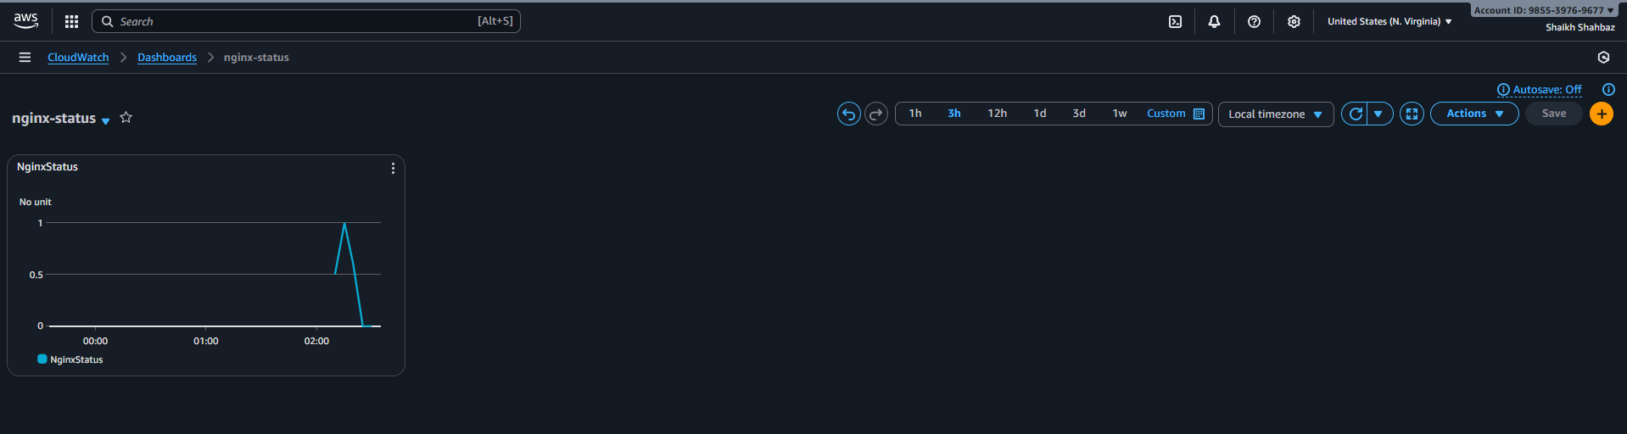
Validation Steps (With Evidence)
Validation 1: Stop Nginx
sudo systemctl stop nginx
Evidence: Service inactive screenshot
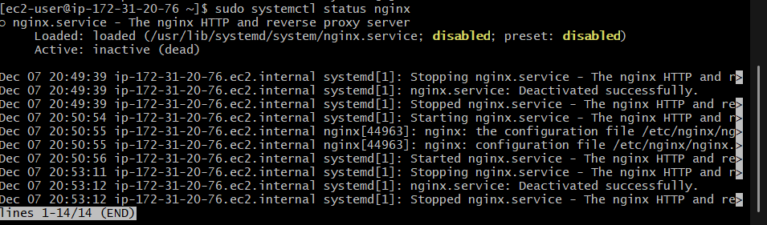
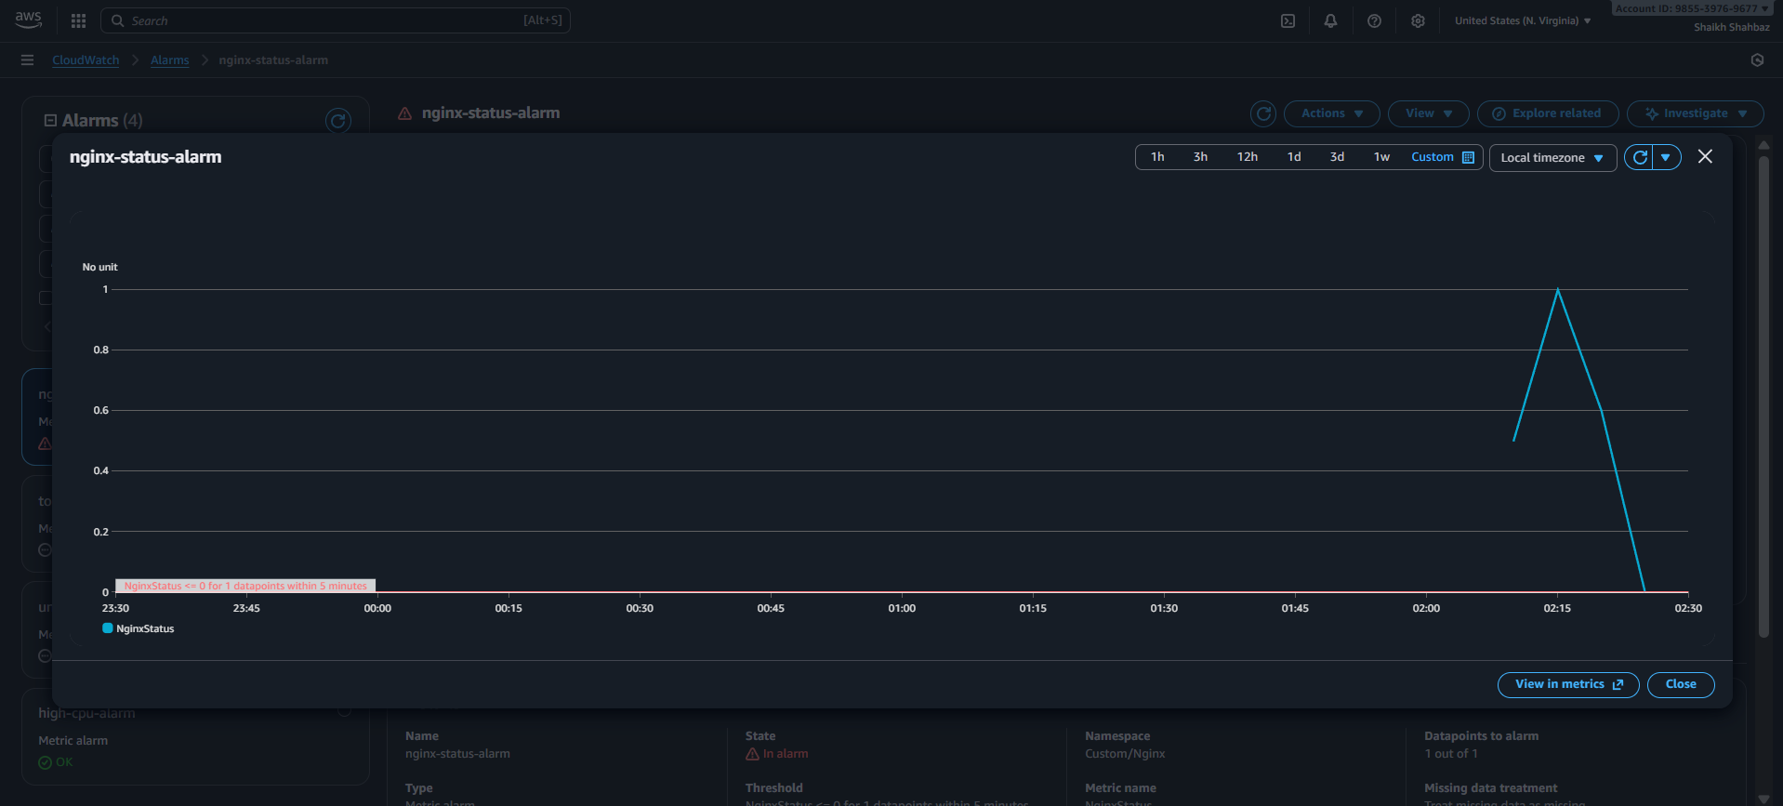
Validation 2: Alarm Fired
Evidence: Alarm in ALARM state
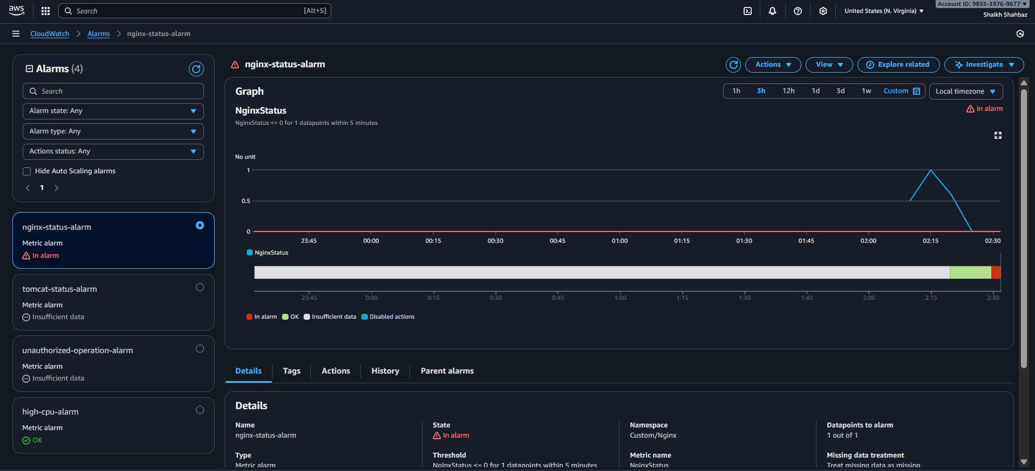
Validation 3: SNS Email Alert
Evidence: Email screenshot
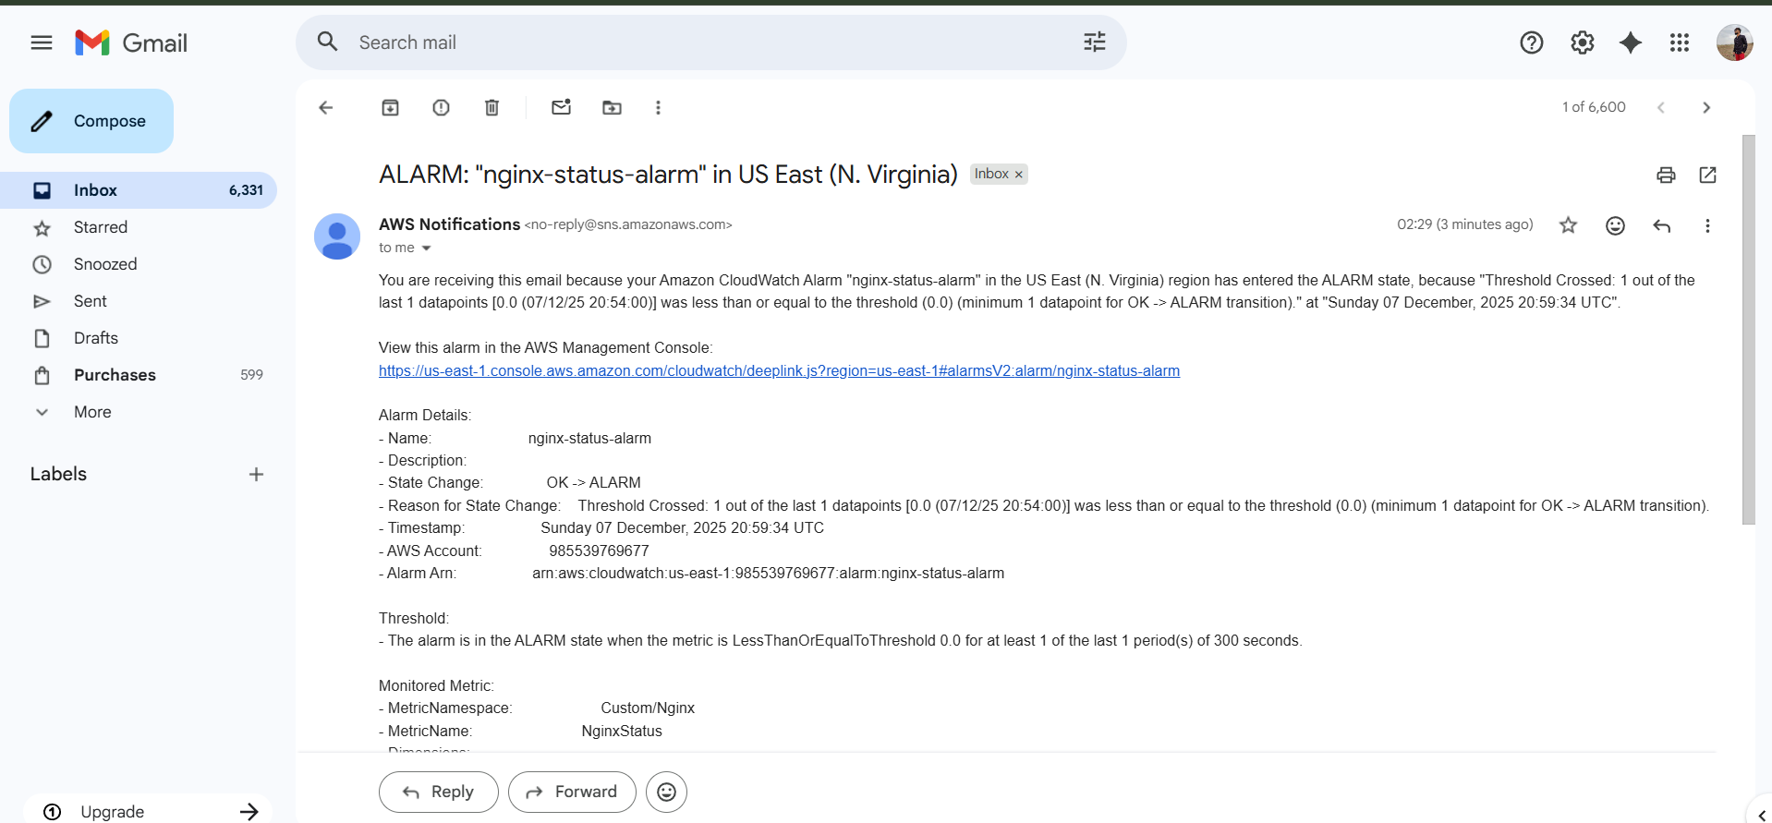
Issues Faced :
None.
Conclusion :
Nginx monitoring and alerting dashboard successfully created.

